CACC’s Pray-In-Place Prayer Meeting
Sunday mornings at 9:30

“We have not ceased to pray for you, asking that you may be filled with the knowledge of his will in all spiritual wisdom and understanding, so as to walk in a manner worthy of the Lord, fully pleasing to him, bearing fruit in every good work and increasing in the knowledge of God” (Colossians 1:9–10).

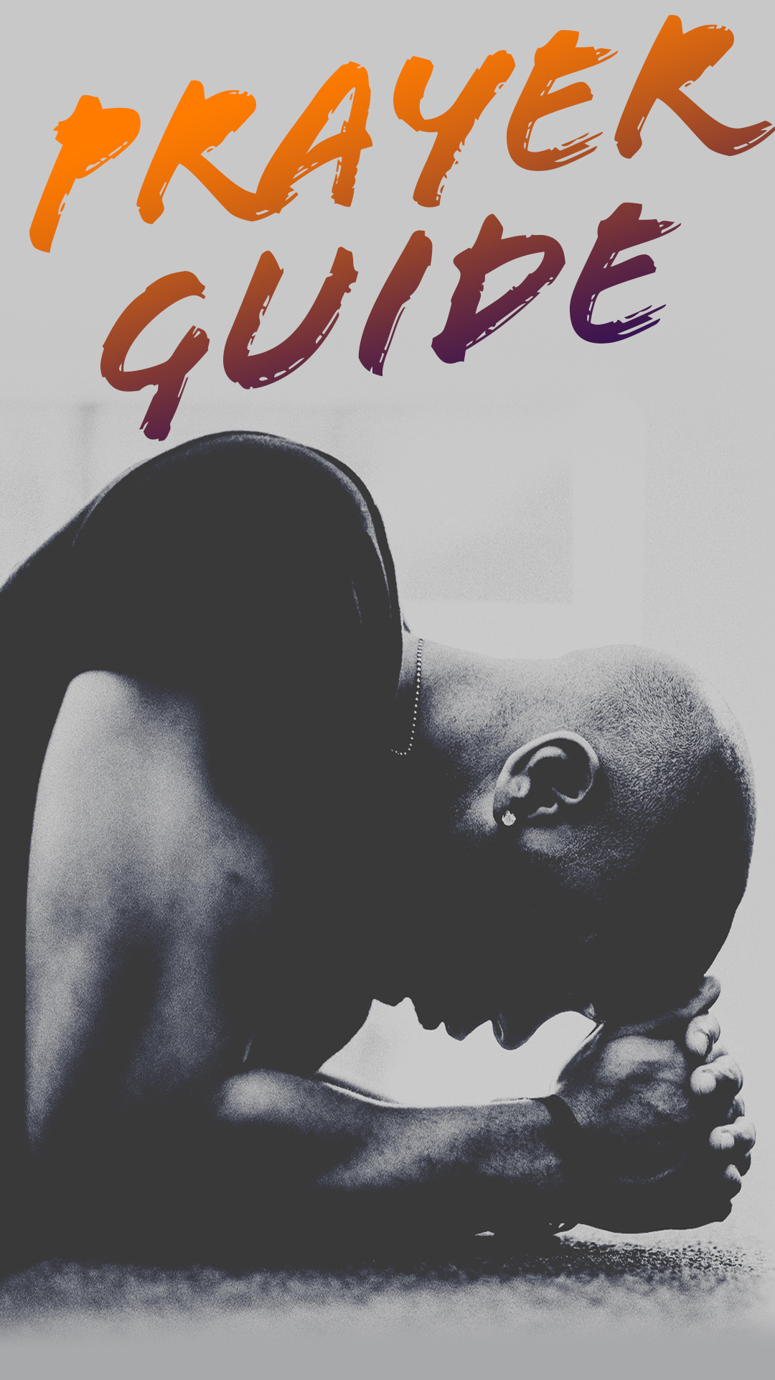
Praise
- Praise God for His power to handle anything we face.
- Praise Him for His incredible love for us.
Thanksgiving
- Thank God for His provision and His promise to never leave us or forsake us (Heb. 13:5)
- Give thanks for the healthcare workers who are working despite the risk to their own health.
- Give thanks for doctors and scientists who God has blessed with the ability to treat us when we’re sick and develop medicines and vaccines.
- Give thanks for the technology that keeps us connected, even when we can’t gather together.
- Give thanks for Christian brothers and sisters who care for one another.
Petition
- Pray for forgiveness for sin (be specific). Ask for the strength to forgive others.
- Pray for faith to trust God and not fear.
- Pray for those most at risk from this virus (the elderly, medical workers, those in already poor health).
- Pray for those who are isolated and alone.
- Pray for our healthcare workers.
- Pray for medicines and vaccines to be developed.
- Pray for those whose jobs have been affected by the shutdowns.
- Pray for our leaders to make wise decisions.
- Pray for our country to become united.
- Pray for the church to be a beacon of love and hope through this, that the world might come to Christ.
- Pray for God’s will to be done through this crisis.
- Pray for those on our church prayer list.

