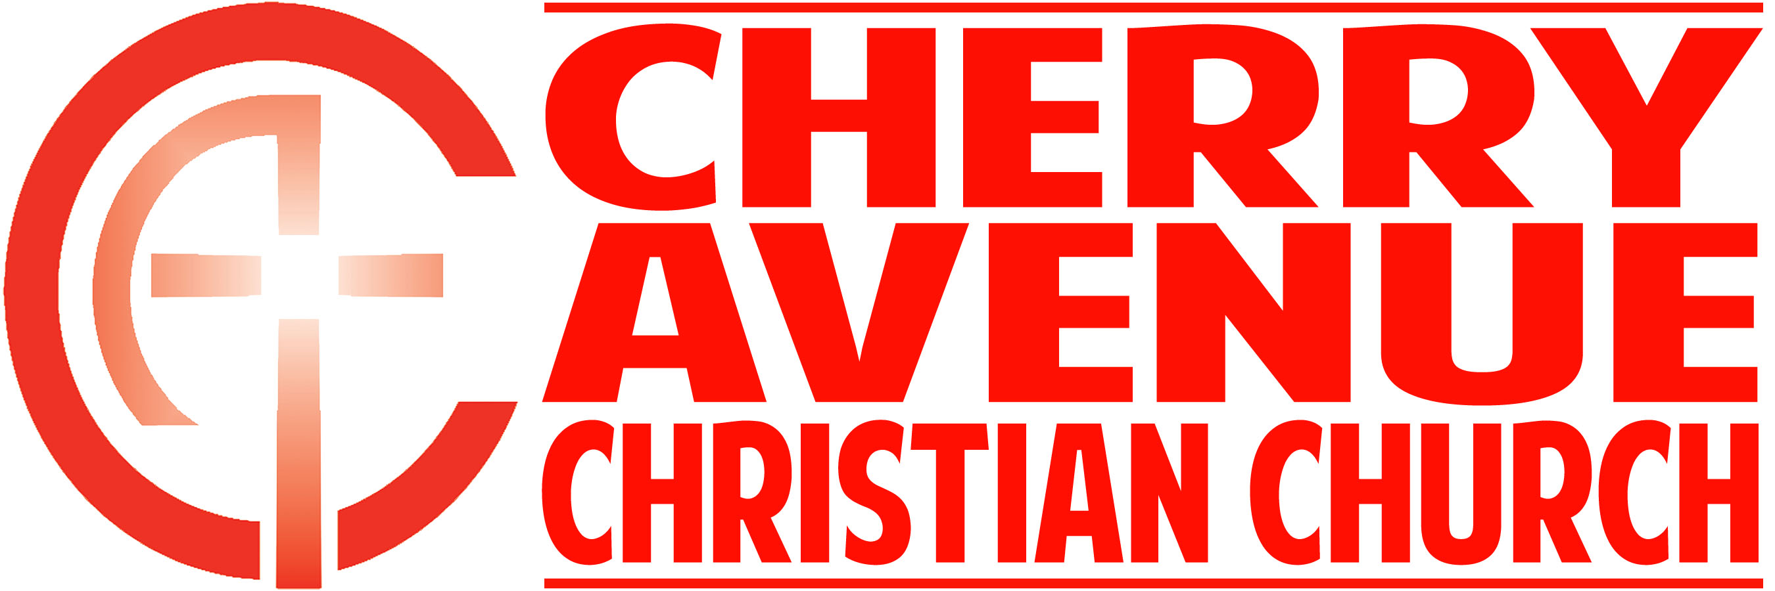
This Changes Everything
Matthew 28:1-20
April 12, 2020

Introduction: The tendency to live in ____________ world with a _________________ mindset.

- We live in a new covenant _____________ with an old covenant _______________.

- Toward the end of Jesus' ministry on earth, he had come to be seen more and more as a __________ to the religious establishment.

- But here's something those in power didn't ______________.

- They fell at his feet and ____________________ him.

- The resurrection of Jesus Christ turns the old way of living — and our old approach to making sense of the world around us — completely _____________ _________.

- You need to let go of yesterday's ___________.

- The literal translation of this phrase in Greek is: ________ _____________ afraid.

- The fears we face are all-but-_______________ to the fears the disciples faced during that dreadful weekend.

- It's when we think that Jesus is ___________in the ___________.

- Instead of giving in to fear... You need to give Jesus the ________________he deserves.

- He is worthy to be _____________, worthy to be _____________, worthy to be ____________.

- We need to keep in mind that there will always be those who don't quite get it — even when the __________ is right in front of them.

- Go back to the empty tomb and ________ at where he _______.

- You need to live every day as if he is __________ you all the way — because he is.

- We feel the fear that we feel because we feel that we are _________ — vulnerable and unprotected.

- You don't need to ________ ______ him, you only need to ________ ____ him — because he is already here.

CONCLUSION; You're living your life based on _______ news and ____________ information.

