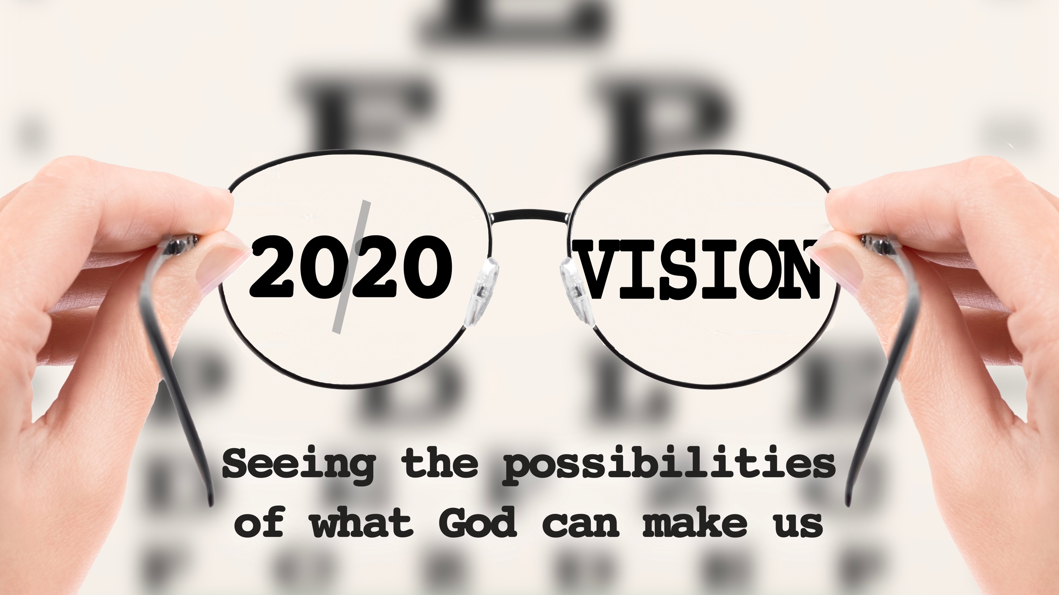
Branches on the Vine
20/20 Vision, part one
John 15

“I am the vine; you are the branches. If you remain in me and I in you, you will bear much fruit; apart from me you can do nothing.” John 15:5 (NIV)

Jesus wants us to be _____________ on the ________.

We produce __________ when we’re ___________ to the vine.

The branch understands that _____________ is the _________’s job.

“I am the true vine.” John 15:1 (NIV)

We must avoid ______________ vines.

“I have told you this so that my joy may be in you and that your joy may be complete.” John 15:11 (NIV)

“If you do not remain in me, you are like a branch that is thrown away and withers; such branches are picked up, thrown into the fire and burned.” John 15:6 (NIV)

A branch that is not ___________ to the vine is a ________.

What do branches on the vine look like?
They are _____________.

“If you keep my commands, you will remain in my love, just as I have kept my Father’s commands and remain in his love.” John 15:10 (NIV)

They _____________ others.

“Love each other as I have loved you.” John 15:12 (NIV)

They are _________ things that they can’t do ____ _____ _____.

“If you remain in me and my words remain in you, ask whatever you wish, and it will be done for you.” John 15:7 (NIV)

