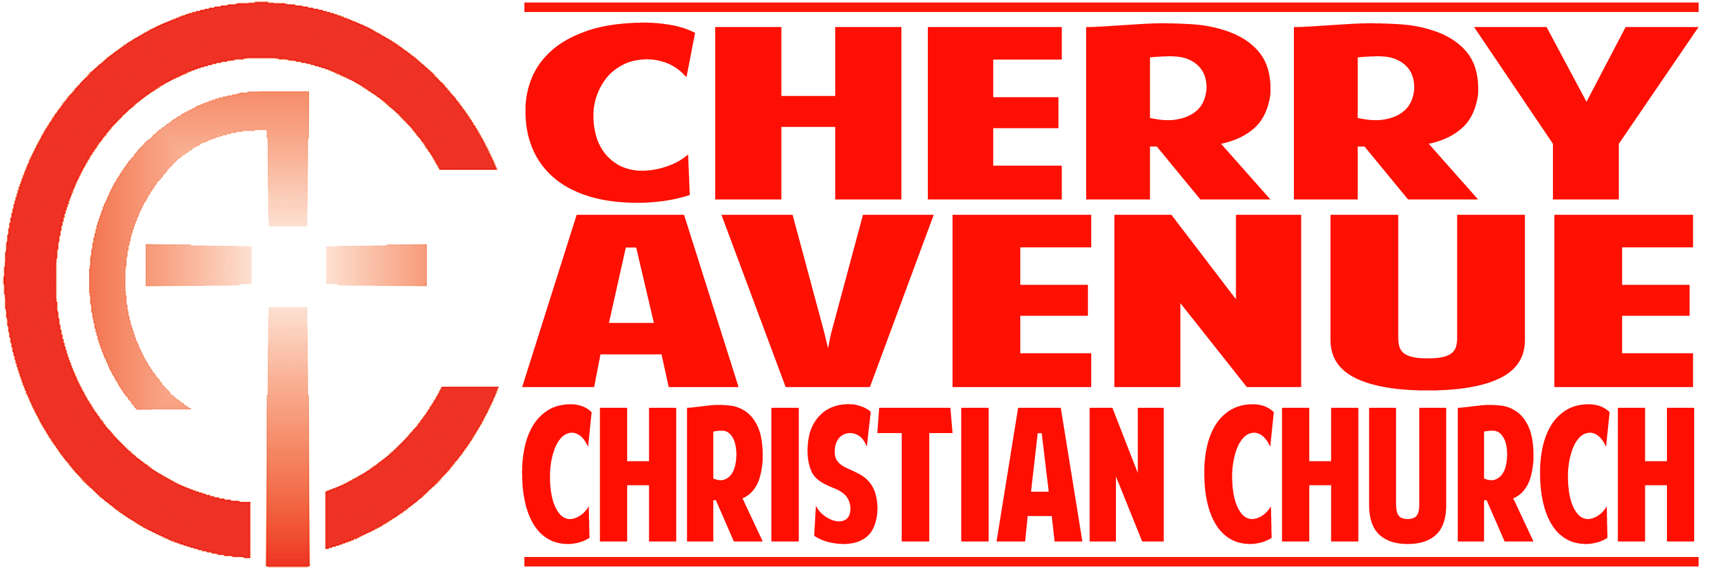
Live Like a Christian
I Thessalonians 5:12-24

INTRODUCTION: To the Apostle, the mark of true Christian faith is that it changes everything you _____ and ______.

- How we are to act toward the ___________________ of the church

- Paul intended that this word should set the _________________ of behavior for the believers in the congregation at Thessalonica.

- There are three things which _____________ _______________ must do with regard to their leaders:

- ______________________ them.

- ____________ them.

- Live in _____________ with each other.

- Paul gives three reasons for this _________ of leaders:

- Leaders are _________ by the Lord.

- The word is literally, "to put in __________."

- They _________ hard.

- Paul addresses our behavior toward _______ ________________ in the body.

- We need to keep our eyes open to the ___________ of others among us.

- “Every time you encounter another person, you have the opportunity to practice _________________.”

- This is the mark of character: the difference between being _________-centered and being ______________-centered.

- We need to focus our eyes to what is ____________ going on around us.

- We need to keep our eyes open to the _________________ of God within us.

CONCLUSION: Character is _________________ in the context of a Christian community, and it is _______________ in the context of a community.

