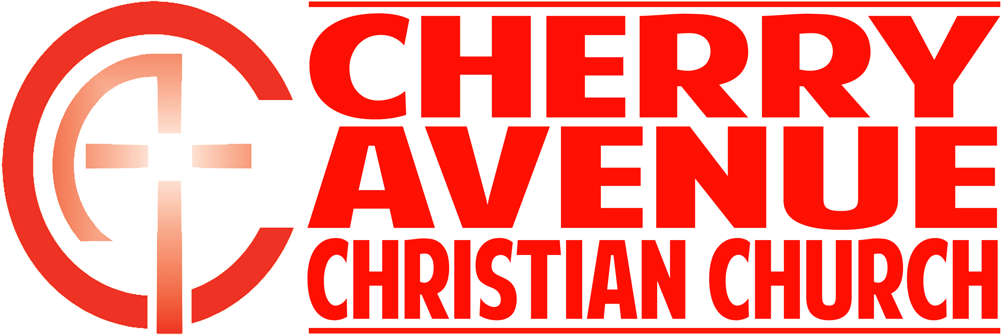
WHAT IF I MADE THE WORLD A BETTER PLACE?
Deuteronomy 34:1-12

- You will be mourned, but not ___________.

- No matter who it is that is gone, life _________ _____.

- No matter who you are: You will be mourned for a ___________.

- Devote yourself to a ___________ that will outlive you.

- A failure in ________________.

- If you want to live to make a difference, you need to devote yourself to something that is _____________ than you.

- Invest in building those who will _________ ___________you.

- One of the most important works that Moses did in his entire life was that he ________________ Joshua to take his place.

CONCLUSION: Do you want to make the world a better place?

- The ___________ of the race is to become more like Christ.

- The ___________ is Christ at work in me and through me to the world.

- The race is the _______________ of becoming like the one I’m running toward, Jesus Christ.

- Make it your life's work to help people.

