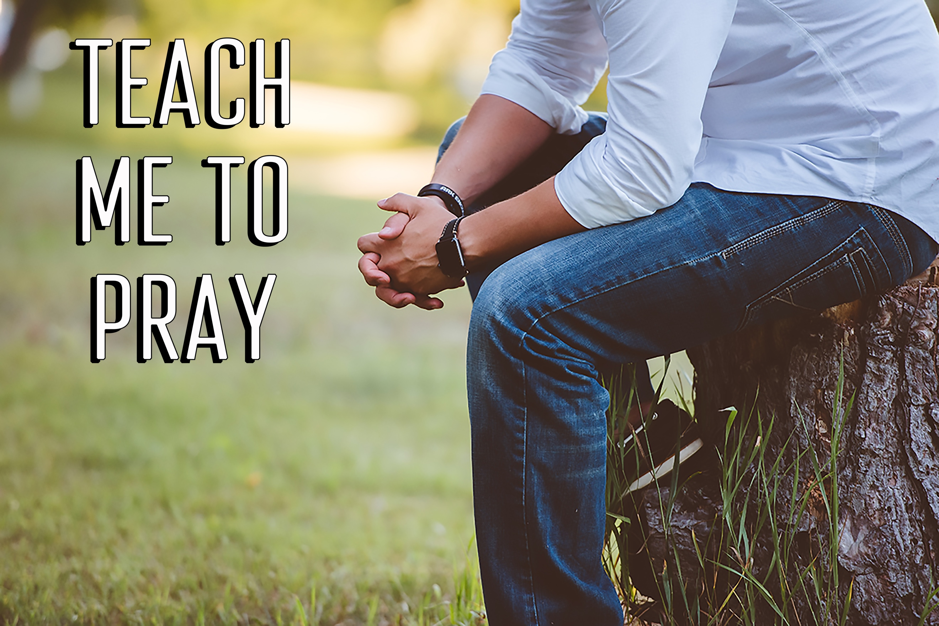
Take a Knee
Teach Me to Pray, part two
Acts 9

³⁶ “In Joppa there was a disciple named Tabitha (in Greek her name is Dorcas); she was always doing good and helping the poor. ³⁷ About that time she became sick and died, and her body was washed and placed in an upstairs room…. ⁴⁰ Peter sent them all out of the room; then he got down on his knees and prayed. Turning toward the dead woman, he said, “Tabitha, get up.” She opened her eyes, and seeing Peter she sat up. ⁴¹ He took her by the hand and helped her to her feet. Then he called for the believers, especially the widows, and presented her to them alive. ⁴² This became known all over Joppa, and many people believed in the Lord.” Acts 9:36-37, 40-42 (NIV)

“When Paul had finished speaking, he knelt down with all of them and prayed.”
Acts 20:36 (NIV)

“When it was time to leave, we left and continued on our way. All of them, including wives and children, accompanied us out of the city, and there on the beach we knelt to pray.” Acts 21:5 (NIV)

There were two common characteristics of the early church’s times of praying on their knees: _______________ & ________________.

“Come let us worship and bow down, let us kneel before the Lord our Maker.”
Psalm 95:6 (NIV)

Because it’s _________ power, we are more powerful on our _______ than we are on our _______.

“Confess your sins to each other and pray for each other so that you may be healed. The prayer of a righteous person is powerful and effective.” James 5:16 (NIV)

Kneeling in prayer should be an outward sign of our _________.

