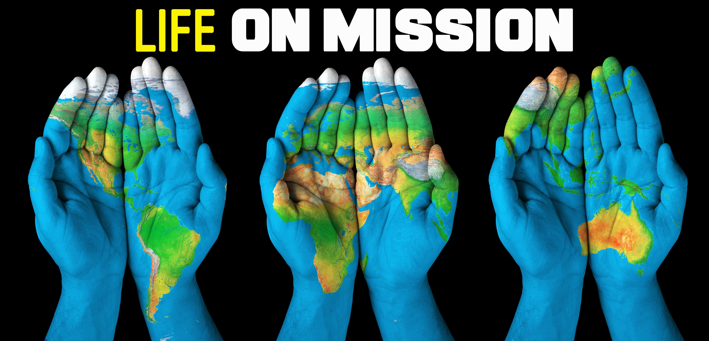
Gone Fishin’
Life on Mission, part two

“Follow me, and I will make you fishers of men.”
Matthew 4:19 (KJV)

“But in your hearts set apart Christ as Lord. Always be prepared to give an answer to everyone who asks you to give the reason for the hope that you have. But do this with gentleness and respect.” 1 Peter 3:15 (NIV)

Two parts of sharing your faith:
- ____________ it out – Approach each day trying to grow closer to God, and being available for Him to use to influence others.
- ____________ it out – Be ready to share my story and God’s story when the opportunities arise.

Guidelines for sharing your story:
Keep it ______________ (<100 words)
Keep it ______________
Keep it ______________

"For God so loved the world that he gave his one and only Son, that whoever believes in him shall not perish but have eternal life.” John 3:16 (NIV)

What we have to know to become a Christian:
God ________________ the world; God ____________ his son to take the punishment for our sins.

What we have to do to become a Christian:
We _______________ ____ Him (trust in Jesus to save us)

“When the people heard this, they were cut to the heart and said to Peter and the other apostles, ‘Brothers, what shall we do?’ Peter replied, ‘Repent and be baptized, every one of you, in the name of Jesus Christ for the forgiveness of your sins. And you will receive the gift of the Holy Spirit.’” Acts 2:37-38 (NIV)

How do we put our trust in Christ?
- We _________________ (turn our heart and mind to God)
- We are ____________________.

When we believe, we ___________________--forgiveness for our sins, and the gift of God’s Spirit.

