OBS December 8
Jesus before Pilate & On the Cross
Matthew 27:15-44

Releasing a prisoner to the crowd was a kind of ____________ ____________ designed to ___________ the crowd and keep them _____________.

Barabbas was likely more of a Jewish ________ who did something against the __________ that would make him _____________ with the people.

Since people were looking to a ______________ Messiah, Jesus’ arrest and the _____________ against Him made it seem to them like He wasn’t the Messiah after all.

Our _______ put Jesus on the cross, just as the crowd’s shout of “Crucify Him” did.

Pilate’s desire to keep __________ was stronger than his desire for ____________.

Crucifixion was usually reserved for ___________ and the __________ criminals.

There were four types of crosses the Romans used:
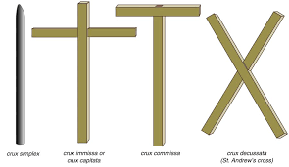

Beyond the physical torture, Jesus had to endure hearing people He created and loved and was dying for hurl _____________ at Him.

