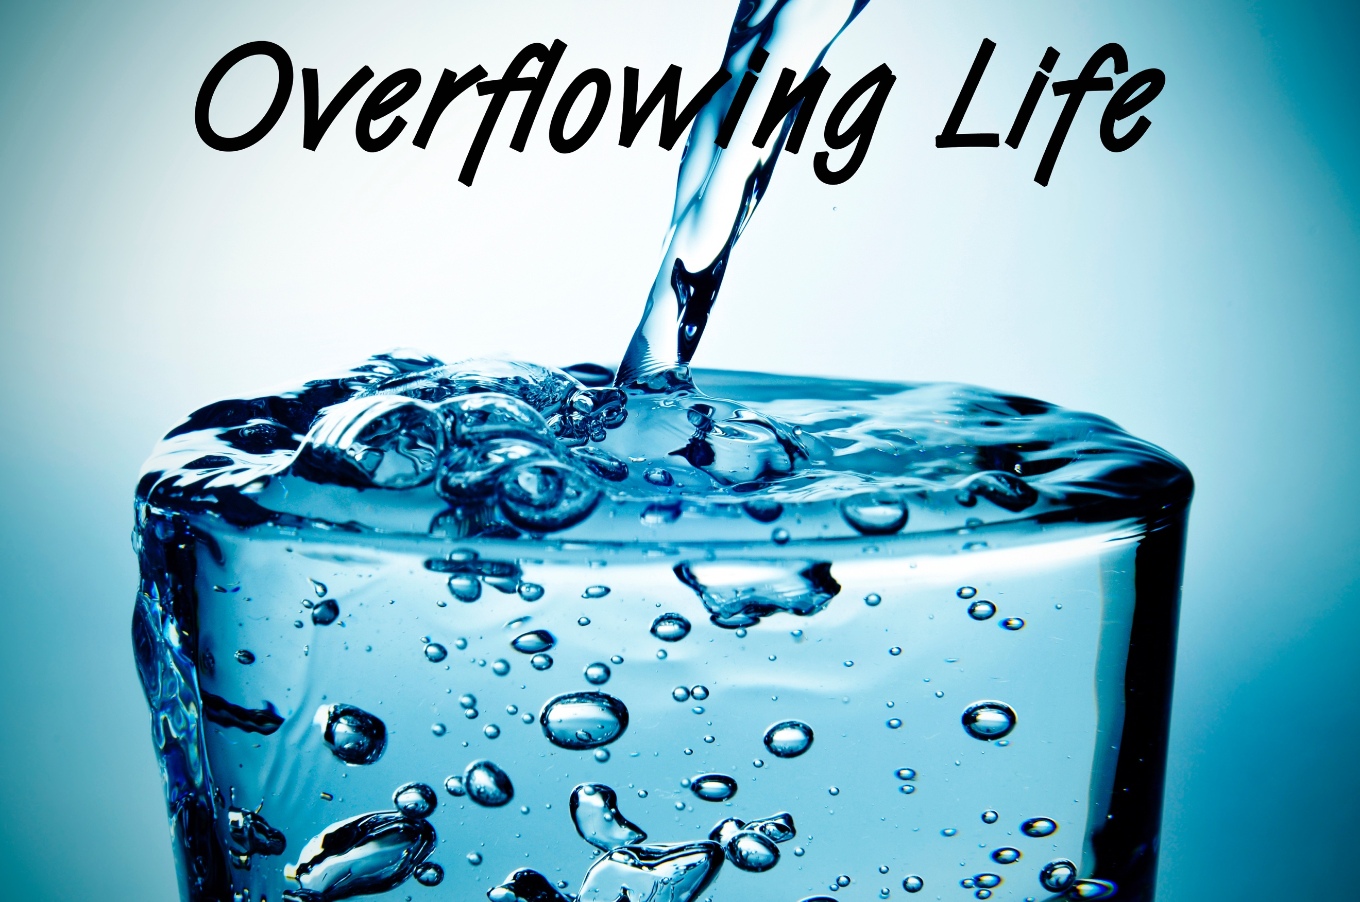
Overflowing Power
Overflowing Life, part four
1 Thessalonians 4:1-8

1 Thessalonians 4:1-8 (NIV)
“As for other matters, brothers and sisters, we instructed you how to live in order to please God, as in fact you are living. Now we ask you and urge you in the Lord Jesus to do this more and more. ² For you know what instructions we gave you by the authority of the Lord Jesus.
³ It is God’s will that you should be sanctified: that you should avoid sexual immorality; ⁴ that each of you should learn to control your own body^{[a]} in a way that is holy and honorable, ⁵ not in passionate lust like the pagans, who do not know God; ⁶ and that in this matter no one should wrong or take advantage of a brother or sister.” ⁷ For God did not call us to be impure, but to live a holy life. ⁸ Therefore, anyone who rejects this instruction does not reject a human being but God, the very God who gives you his Holy Spirit.”

If you’re a Christian, then living to ___________ God should ___________ to you.

The longer you’re a Christian, the more you should _______ like ___________.

God created sex as a gift that’s not just ____________; it’s inextricably tied to our ______________ and our ____________ walk.

Why we should follow God’s will in this:
Controlling your body sexually is _____________.

Sexual immorality is evidence that you don’t __________ God.

Sexual immorality __________ _____________.

“And that is what some of you were. But you were washed, you were sanctified, you were justified in the name of the Lord Jesus Christ and by the Spirit of our God.”
1 Corinthians 6:11 (NIV)

All sins are _______ in that they ____________ us from God, but they’re not equal in the ____________ they have on us.

God gave us His Spirit to give us ____________ to ____________ the _____ in our life.

