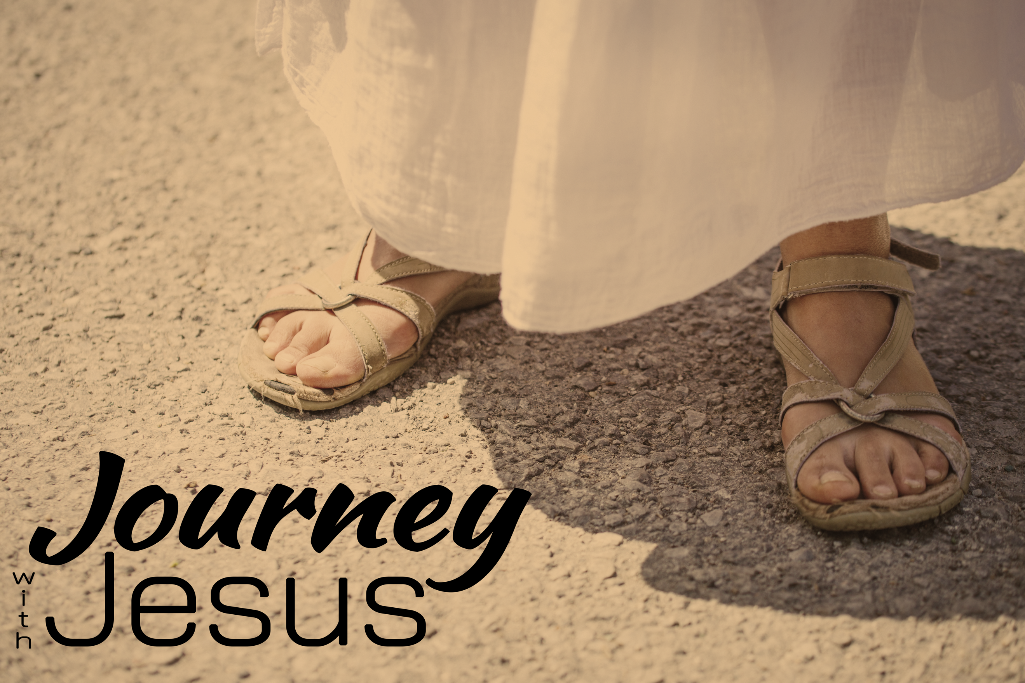
Opening Day
Journey with Jesus, part one
Luke 3:1-3; John 1:15, 17, 19-29

“In the fifteenth year of the reign of Tiberius Caesar—when Pontius Pilate was governor of Judea, Herod tetrarch of Galilee, his brother Philip tetrarch of Iturea and Traconitis, and Lysanias tetrarch of Abilene— ² during the high-priesthood of Annas and Caiaphas, the word of God came to John son of Zechariah in the wilderness. ³ He went into all the country around the Jordan, preaching a baptism of repentance for the forgiveness of sins.” Luke 3:1-3 (NIV)

“This is the one I spoke about when I said, ‘He who comes after me has surpassed me because he was before me.’” John 1:15 (NIV)

“The law was given through Moses; grace and truth came through Jesus Christ.”
John 1:17 (NIV)

“The Jewish leaders in Jerusalem sent priests and Levites to ask him who he was. ²⁰ He did not fail to confess, but confessed freely, “I am not the Messiah.” ²¹ They asked him, “Then who are you? Are you Elijah?” He said, “I am not.”
“Are you the Prophet?” He answered, “No.” ²² Finally they said, “Who are you? Give us an answer to take back to those who sent us. What do you say about yourself?”
²³ John replied in the words of Isaiah the prophet, “I am the voice of one calling in the wilderness, ‘Make straight the way for the Lord.’”
²⁴ Now the Pharisees who had been sent ²⁵ questioned him, “Why then do you baptize if you are not the Messiah, nor Elijah, nor the Prophet?” ²⁶ “I baptize with water,” John replied, “but among you stands one you do not know. ²⁷ He is the one who comes after me, the straps of whose sandals I am not worthy to untie.” John 1:19-27 (NIV)

“You brood of vipers! Who warned you to flee from the coming wrath? ⁸ Produce fruit in keeping with repentance.” Matthew 3:7-8 (NIV)

“Look, the Lamb of God, who takes away the sin of the world!” John 1:29 (NIV)

Israel wasn’t the _________; they were the ________ to the _____. The end was to provide ____________ to the ________.

Jesus came to establish a new ___________ between man and God.

Just as Jesus was starting something new, we can be _______ _____ in Him.

