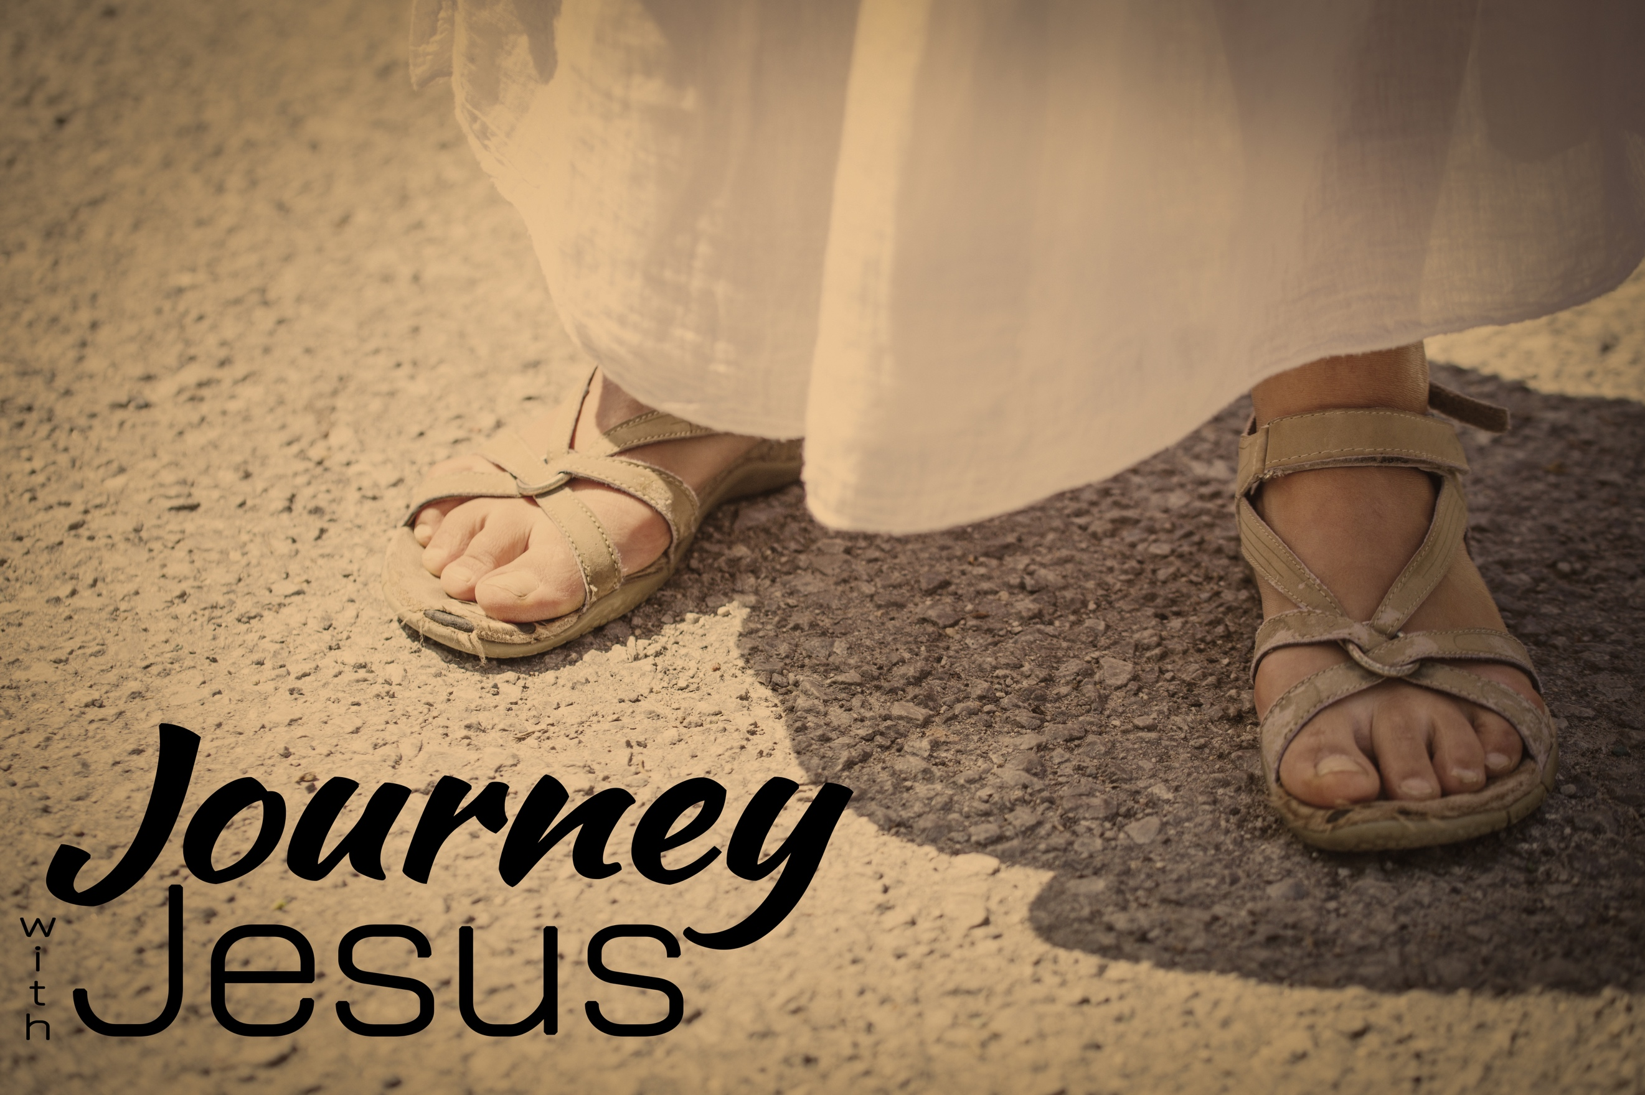
Out with the Old, In with the New
Journey with Jesus, part four
Matthew 5:3-18; Matthew 28:19-20

³ Blessed are the poor in spirit, for theirs is the kingdom of heaven.
⁴ Blessed are those who mourn, for they will be comforted.
⁵ Blessed are the meek, for they will inherit the earth.
⁶ Blessed are those who hunger and thirst for righteousness, for they will be filled.
⁷ Blessed are the merciful, for they will be shown mercy.
⁸ Blessed are the pure in heart, for they will see God.
⁹ Blessed are the peacemakers, for they will be called children of God.
¹⁰ Blessed are those who are persecuted because of righteousness,
for theirs is the kingdom of heaven.
¹¹ “Blessed are you when people insult you, persecute you and falsely say all kinds of evil against you because of me. ¹² Rejoice and be glad, because great is your reward in heaven, for in the same way they persecuted the prophets who were before you.
¹³ “You are the salt of the earth…. ¹⁴ “You are the light of the world…. ¹⁶ In the same way, let your light shine before others, that they may see your good deeds and glorify your Father in heaven.
¹⁷ “Do not think that I have come to abolish the Law or the Prophets; I have not come to abolish them but to fulfill them. ¹⁸ For truly I tell you, until heaven and earth disappear, not the smallest letter, not the least stroke of a pen, will by any means disappear from the Law until everything is accomplished.

Jesus came to __________ the law, and to replace it with something ________; something _________—a covenant between God and ___ mankind.

Jesus established new ____________—ones that went to the _______ ___________ that the laws were _________ on. (vv.21-48)

“So in everything, do to others what you would have them do to you, for this sums up the Law and the Prophets.” Matthew 7:12 (NIV)

“When Jesus had finished saying these things, the crowds were amazed at his teaching, ²⁹ because he taught as one who had authority, and not as their teachers of the law.” Matthew 7:28-29 (NIV)

“All authority in heaven and on earth has been given to me. ¹⁹ Therefore go and make disciples of all nations, baptizing them in the name of the Father and of the Son and of the Holy Spirit, ²⁰ and teaching them to obey everything I have commanded you. And surely I am with you always, to the very end of the age.” Matthew 28:18-20 (NIV)

