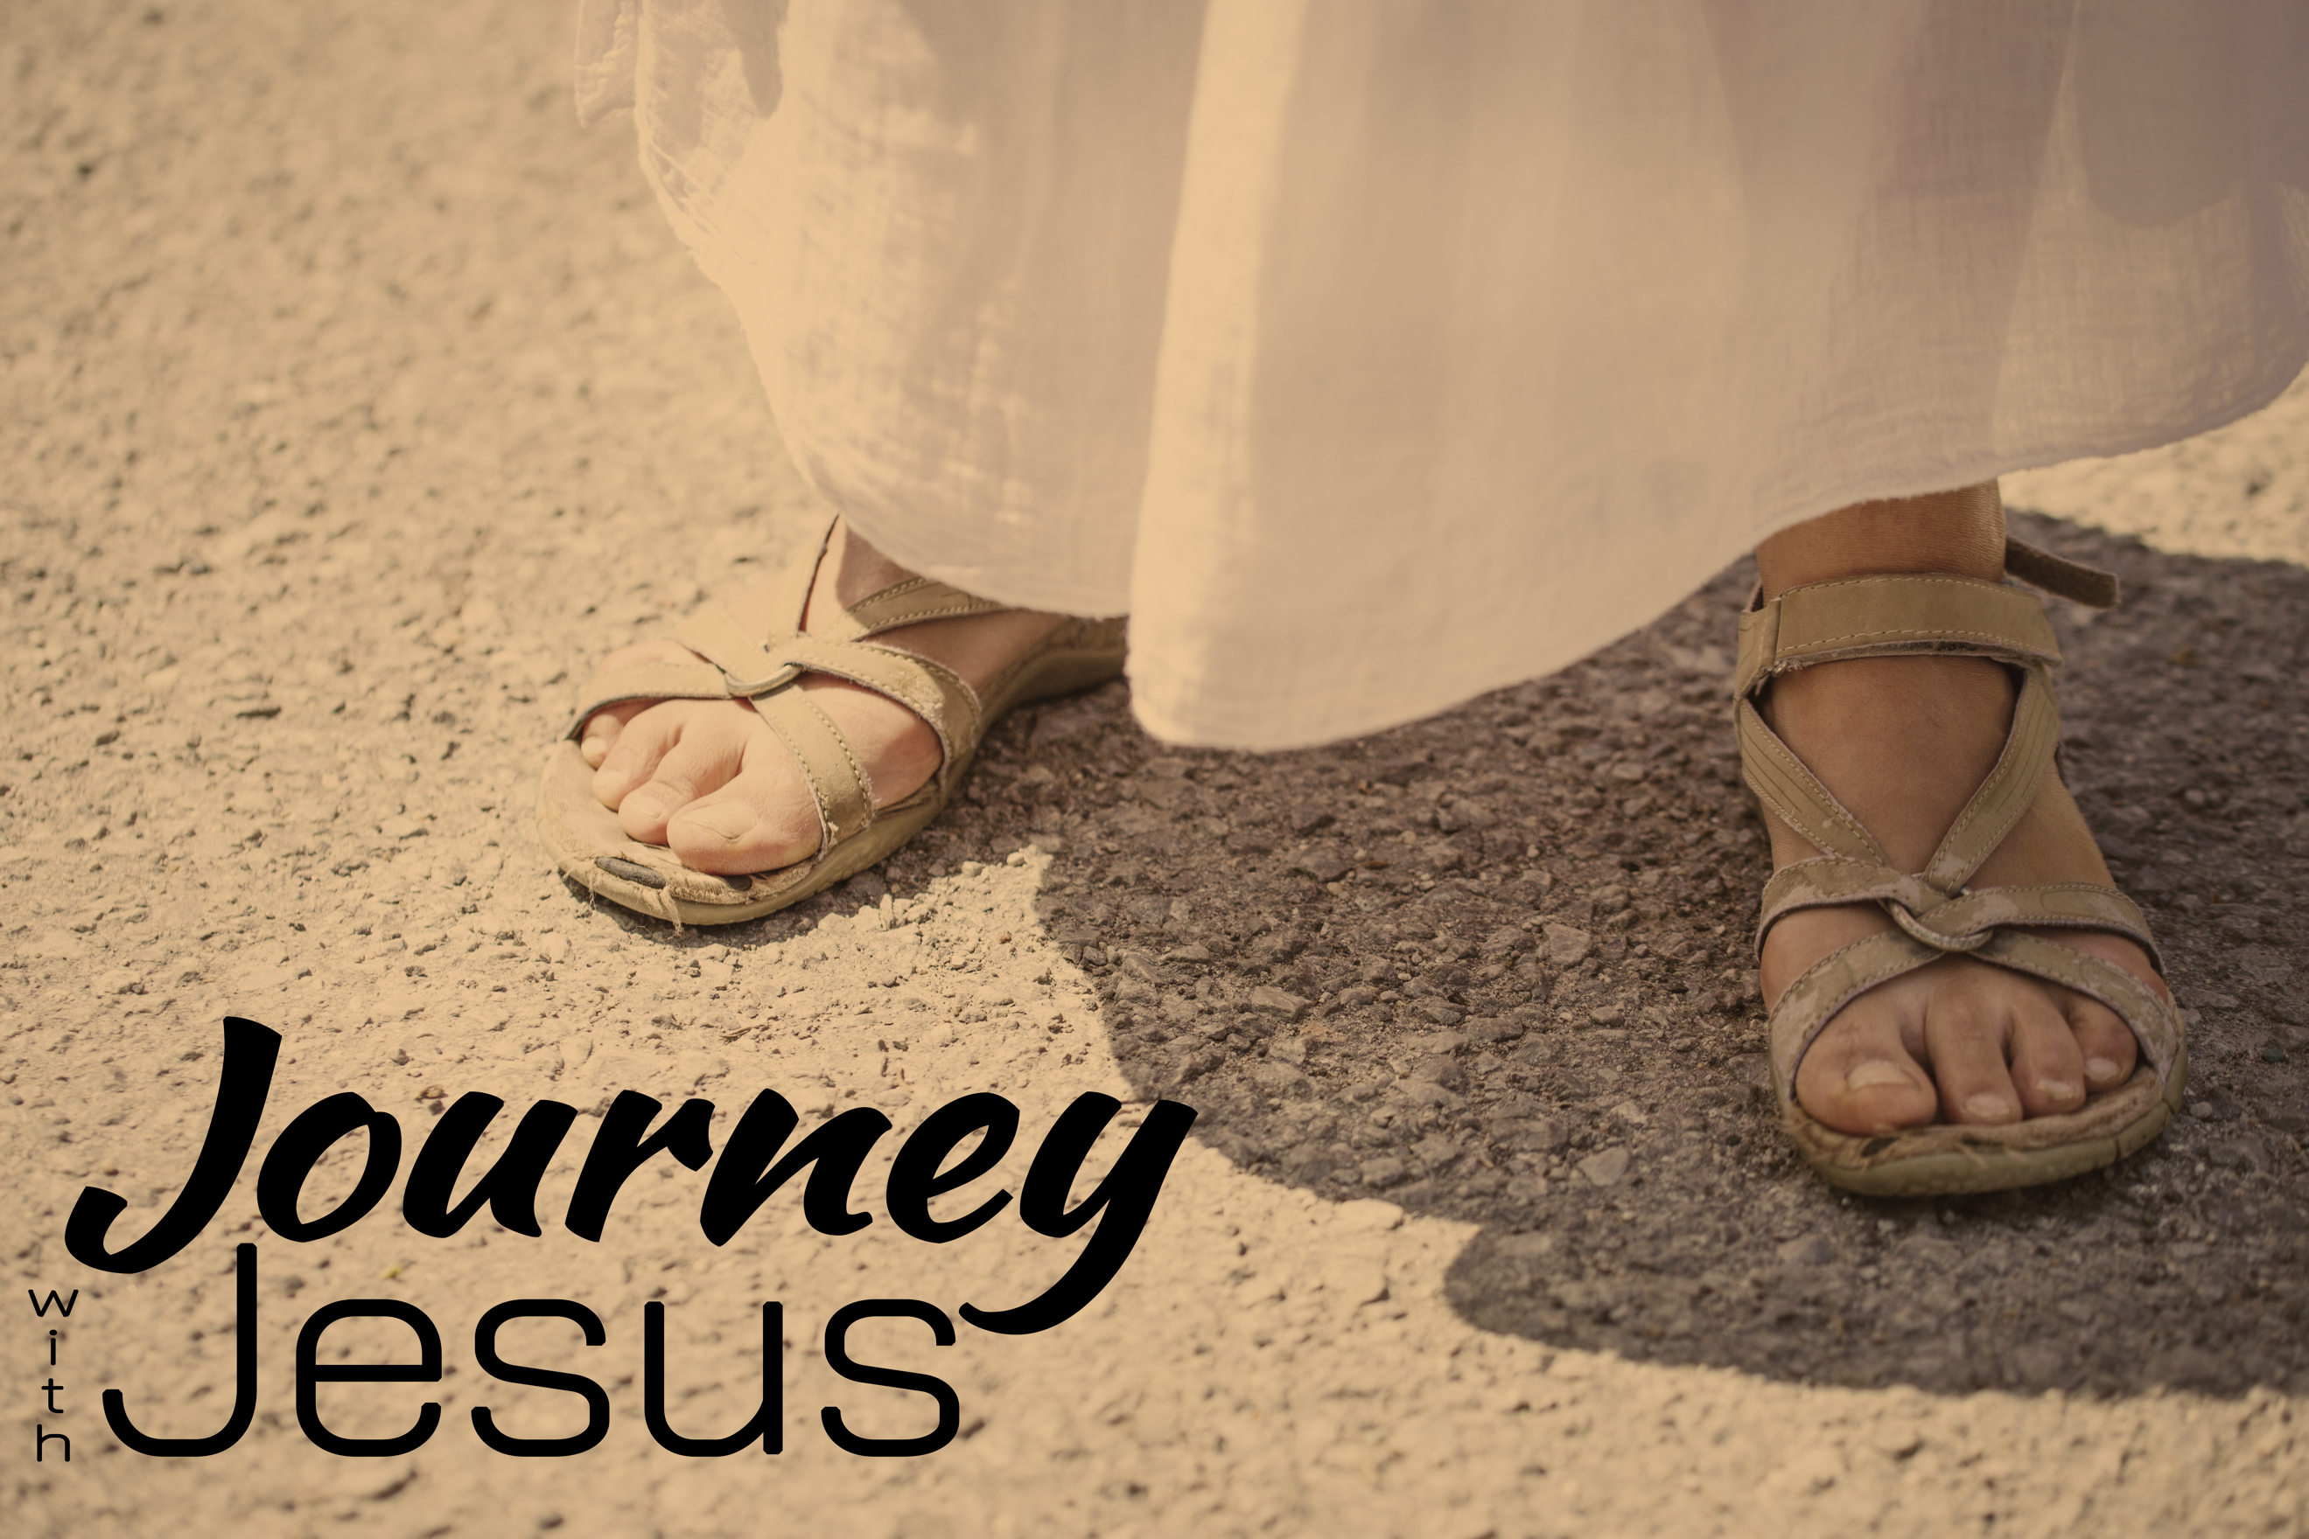
Upside Down
Journey with Jesus, part two
Matthew 4:1-10; Luke 4:13-14

If you spend your life focused on _________ ________, you _____ __________.
Matthew 4:1-10 (NIV)
Then Jesus was led by the Spirit into the wilderness to be tempted by the devil. ² After fasting forty days and forty nights, he was hungry. ³ The tempter came to him and said, “If you are the Son of God, tell these stones to become bread.”
⁴ Jesus answered, “It is written: ‘Man shall not live on bread alone, but on every word that comes from the mouth of God.’”
⁵ Then the devil took him to the holy city and had him stand on the highest point of the temple. ⁶ “If you are the Son of God,” he said, “throw yourself down. For it is written: “‘He will command his angels concerning you, and they will lift you up in their hands, so that you will not strike your foot against a stone.’”
⁷ Jesus answered him, “It is also written: ‘Do not put the Lord your God to the test.’”
⁸ Again, the devil took him to a very high mountain and showed him all the kingdoms of the world and their splendor. ⁹ “All this I will give you,” he said, “if you will bow down and worship me.”
¹⁰ Jesus said to him, “Away from me, Satan! For it is written: ‘Worship the Lord your God, and serve him only.’”

Throughout His ministry, Jesus didn’t just _________, He ___________ what He taught.

Jesus came to establish a different type of kingdom: A ___________ kingdom in our __________.

“When the devil had finished all this tempting, he left him until an opportune time.”
Luke 4:13 (NIV)

“Jesus returned to Galilee in the power of the Spirit, and news about him
spread through the whole countryside.” Luke 4:14 (NIV)

What Jesus valued more than the kingdoms of this world was ________.

The question we have to answer: What good is it to gain the __________ of this world if in the end you lose your very ______; your very ________?

