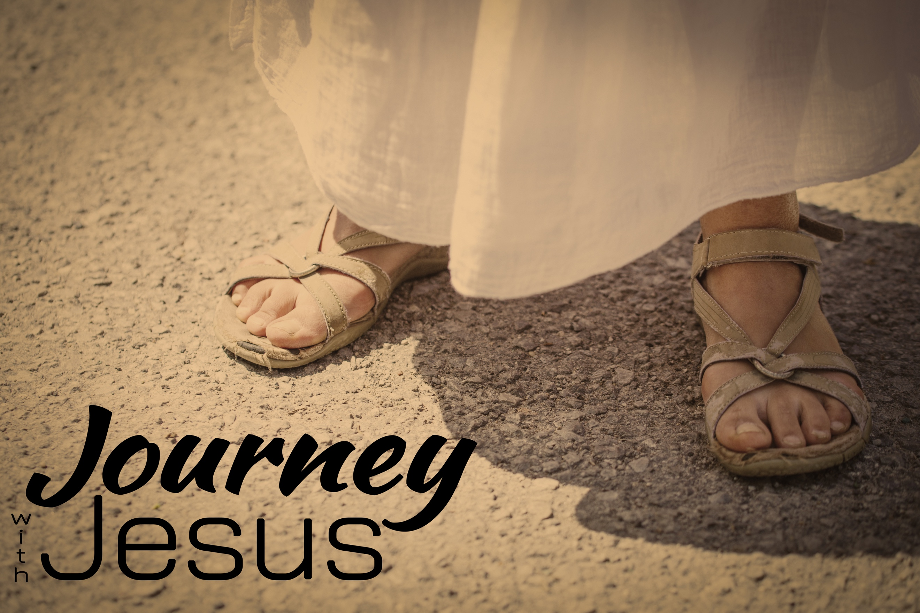
An Old Tradition, A New Meaning
Journey with Jesus, part 7
Matthew 26:26; Luke 22:19-20; Jeremiah 31:31-33

“And they took out palm branches and started waving some of them, some of them they put down on the ground for Him to travel over. And they started shouting “Hosanna! Blessed is he who comes in the name of the Lord! Blessed is the king of Israel!”
John 12:12-13 (NIV)

The crowd assumed Jesus was coming to do something for _________, but He was coming to do something for the whole __________.

“And Judas went to the chief priests and the officers of the temple guard and discussed with them how he might betray Jesus. ⁵ They were delighted and agreed to give him money. ⁶ He consented, and watched for an opportunity to hand Jesus over to them when no crowd was present.” Luke 22:4-6 (NIV)

“While they were eating, Jesus took bread, and when he had given thanks, he broke it and gave it to his disciples, saying, ‘Take and eat; this is my body.’” Matthew 26:26 (NIV)

“In the same way, after the supper he took the cup, saying, ‘This cup is the new covenant in my blood, which is poured out for you.’” Luke 22:20 (NIV)

“The days are coming,” declares the Lord, “when I will make a new covenant
with the people of Israel and with the people of Judah. ³² It will not be like the covenant I made with their ancestors when I took them by the hand to lead them out of Egypt. ³³ “I will put my law in their minds and write it on their hearts.” Jeremiah 31:31-33 (NIV)

Jesus came to establish a new _________—a new _________ between God and man.

“This is my blood of the covenant, which is poured out for many
for the forgiveness of sins.” Matthew 26:28 (NIV)

Jesus established a _________ covenant—where He commits to benefit us _________.

We get the benefits of the covenant by _________ Him: _________ of our sins and being _________ into Him—_________ Him to save us.”

