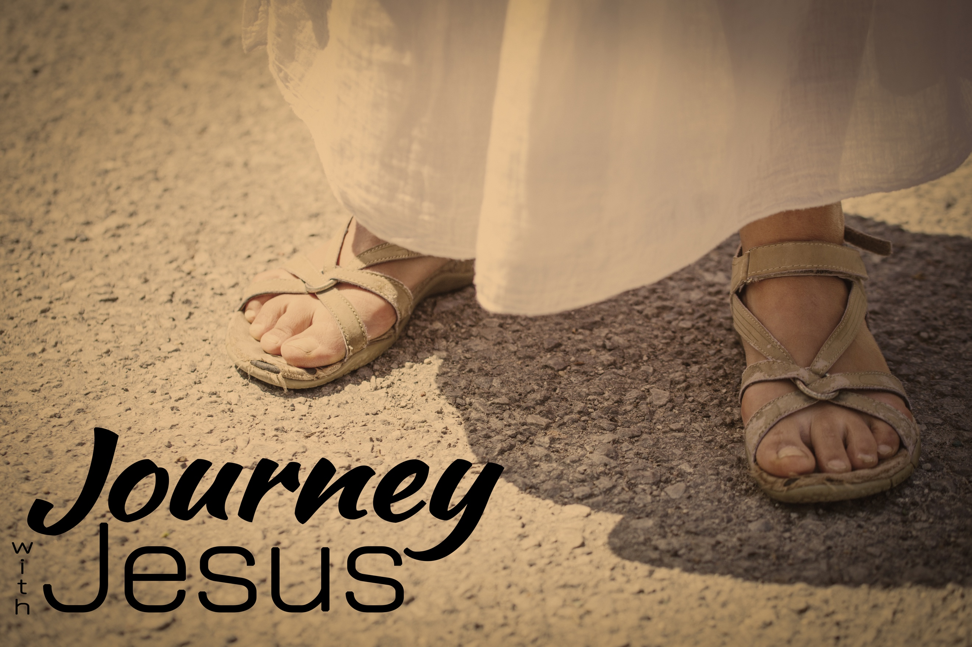
Born (again) Free
Journey with Jesus, part five
John 3:2-17; Acts 2:38

Worshiping the _______ or the _______ more than caring about the _________ it was instituted for is _____________.

“I tell you that something greater than the temple is here.” Matthew 12:6 (NIV)

“’Do you see all these things?’ he asked. ‘Truly I tell you, not one stone here will be left on another; every one will be thrown down.’” Matthew 24:2 (NIV)

“Do you not know that your bodies are temples of the Holy Spirit, who is in you, whom you have received from God?” 1 Corinthians 6:19 (NIV)

The Spirit of God is now living in the _________ of Christians; our _____________ became His _____________.

“Rabbi, we know that you are a teacher who has come from God. For no one could perform the signs you are doing if God were not with him.”
³ Jesus replied, “Very truly I tell you, no one can see the kingdom of God unless they are born again.”
⁴ “How can someone be born when they are old?” Nicodemus asked. “Surely they cannot enter a second time into their mother’s womb to be born!”
⁵ Jesus answered, “Very truly I tell you, no one can enter the kingdom of God unless they are born of water and the Spirit.⁶ Flesh gives birth to flesh, but the Spirit gives birth to spirit.⁷ You should not be surprised at my saying, ‘You must be born again.’ ⁸ The wind blows wherever it pleases. You hear its sound, but you cannot tell where it comes from or where it is going. So it is with everyone born of the Spirit. ⁹ “How can this be?” Nicodemus asked.
¹⁰ “You are Israel’s teacher,” said Jesus, “and do you not understand these things?” John 3:2-10 (NIV)

^{14 “’}Just as Moses lifted up the snake in the wilderness, so the Son of Man must be lifted up, ¹⁵ that everyone who believes may have eternal life in him.’
¹⁶ For God so loved the world that he gave his one and only Son, that whoever believes in him shall not perish but have eternal life.¹⁷ For God did not send his Son into the world to condemn the world, but to save the world through him.” John 3:14-17 (NIV)

How we put our trust in Jesus:
_____________

Be _____________

“Repent and be baptized, every one of you, in the name of Jesus Christ for the forgiveness of your sins. And you will receive the gift of the Holy Spirit.” Acts 2:38 (NIV)

