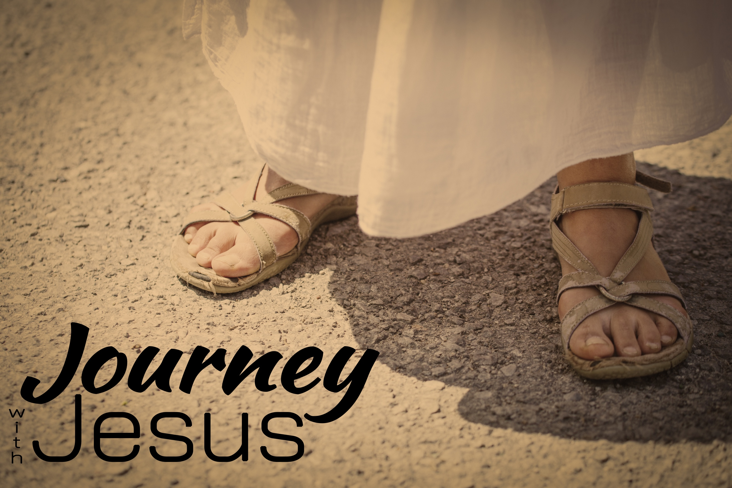
Kangaroo Court
Journey with Jesus, part eight
Mark 14, John 18-19, Luke 23, Matthew 27

“Then everyone deserted him and fled.” Mark 14:50 (NIV)

⁶⁰ Then the high priest stood up before them and asked Jesus, “Are you not going to answer? …. “Are you the Messiah, the Son of the Blessed One?”
⁶² “I am,” said Jesus….
⁶³ The high priest tore his clothes. “Why do we need any more witnesses?” he asked. ⁶⁴ “You have heard the blasphemy. What do you think?” They all condemned him as worthy of death. ⁶⁵ Then some began to spit at him; they blindfolded him, struck him with their fists, and said, “Prophesy!” And the guards took him and beat him.” Mark 14:60-65

It wasn’t until Jesus admitted He was the Messiah that the religious leaders found a ____________ against Him.

“They bound Jesus, led him away and handed him over to Pilate.” Mark 15:1 (NIV)

John 18:28 “By now it was early morning, and to avoid ceremonial uncleanness they did not enter the palace, because they wanted to be able to eat the Passover. ²⁹ So Pilate came out to them and asked, “What charges are you bringing against this man?”
³⁰ “If he were not a criminal,” they replied, “we would not have handed him over to you.”
³¹ Pilate said, “Take him yourselves and judge him by your own law.”
“But we have no right to execute anyone,” they objected…..
³³ Pilate then went back inside the palace, summoned Jesus and asked him, “Are you the king of the Jews?”
³⁴ “Is that your own idea,” Jesus asked, “or did others talk to you about me?”
³⁵ “Am I a Jew?” Pilate replied. “Your own people and chief priests handed you over to me. What is it you have done?”
³⁶ Jesus said, “My kingdom is not of this world….
³⁷ “You are a king, then!” said Pilate.
³⁸“I find no basis for a charge against him.”

Luke 23:5 “He stirs up the people all over Judea by his teaching. He started in Galilee and has come all the way here.”

Luke 23:8 says, “When Herod saw Jesus, he was greatly pleased, because for a long time he had been wanting to see him. From what he had heard about him, he hoped to see him perform a sign of some sort.”

Luke 23:14-16 “You brought me this man as one who was inciting the people to rebellion. I have examined him in your presence and have found no basis for your charges against him.¹⁵ Neither has Herod, for he sent him back to us; as you can see, he has done nothing to deserve death. ¹⁶ Therefore, I will punish him and then release him.”

John 19:7 “The Jewish leaders insisted, ‘We have a law, and according to that law he must die, because he claimed to be the Son of God.’”

John 19:10-16 ¹⁰ “Do you refuse to speak to me?” Pilate said. “Don’t you realize I have power either to free you or to crucify you?”
¹¹ Jesus answered, “You would have no power over me if it were not given to you from above. Therefore the one who handed me over to you is guilty of a greater sin.” ¹² From then on, Pilate tried to set Jesus free, but the Jewish leaders kept shouting, “If you let this man go, you are no friend of Caesar. Anyone who claims to be a king opposes Caesar.”
¹³ When Pilate heard this, he brought Jesus out and sat down on the judge’s seat at a place known as the Stone Pavement….
¹⁴“Here is your king,” Pilate said to the Jews.
¹⁵ But they shouted, “Take him away! Take him away! Crucify him!”
“Shall I crucify your king?” Pilate asked.
“We have no king but Caesar,” the chief priests answered.
¹⁶ Finally Pilate handed him over to them to be crucified.

Pilate tried ______ times to get them to drop the charges against Jesus.

When Jesus died, there was _______ we know of who believed He would _______.

Matthew 27:63-66 ⁶³ “Sir,” they said, “we remember that while he was still alive that deceiver said, ‘After three days I will rise again.’ ⁶⁴ So give the order for the tomb to be made secure until the third day. Otherwise, his disciples may come and steal the body and tell the people that he has been raised from the dead. This last deception will be worse than the first.” ⁶⁵ “Take a guard,” Pilate answered. “Go, make the tomb as secure as you know how.” ⁶⁶ So they went and made the tomb secure by putting a seal on the stone and posting the guard.”

