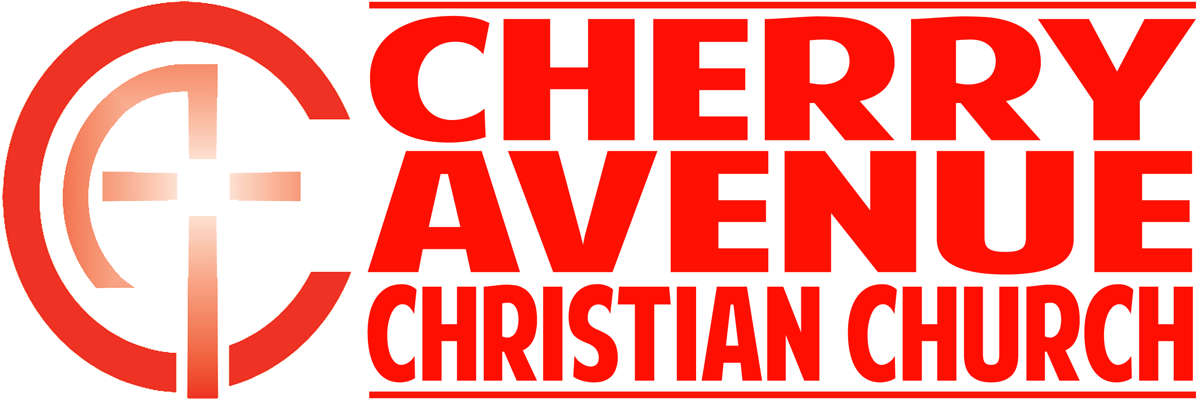
Discovering God’s Will, part two
1 Corinthians 10

When it comes to discovering God’s will in the areas not addressed in Scripture,
The question isn’t “Is it OK?” The question is, “Is it ______________ for me?”

“Everything is permissible”—but not everything is beneficial.” 1 Corinthians 10:23a (NIV ’84)

“Accept him whose faith is weak, without passing judgment on disputable matters.”
Romans 14:1 (NIV ’84)

“Do not destroy the work of God for the sake of food.” Romans 14:20a (NIV ’84)

“So whatever you believe about these things keep between yourself and God.”
Romans 14:22 (NIV ’84)

The question isn’t “Is it OK?” The question is, “Is it ____________ to ________________?”

“Everything is permissible, but not everything is constructive. Nobody should seek his own good, but the good of others.” 1 Corinthians 10:23b-24 (NIV ’84)

“Do not cause anyone to stumble, whether Jews, Greeks or the church of God — even as I try to please everybody in every way. For I am not seeking my own good but the good of many, so that they may be saved.” 1 Corinthians 10:32-33 (NIV ’84)

“So whether you eat or drink or whatever you do, do it all for the glory of God.”
1 Corinthians 10:31 (NIV ’84)

The question isn’t “Is it OK?” The question is, “Is it ______________ to _________?”

