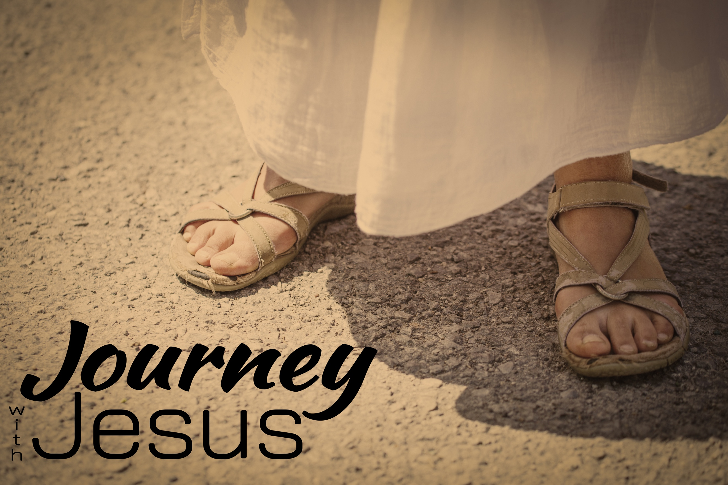
Game Changer
Journey with Jesus, part nine

“Very early on the first day of the week, just after sunrise, they were on their way to the tomb ³ and they asked each other, “Who will roll the stone away from the entrance of the tomb?” Luke 16:2-3 (NIV)

⁴ While they were wondering about this, suddenly two men in clothes that gleamed like lightning stood beside them. ⁵ In their fright the women bowed down with their faces to the ground, but the men said to them, “Why do you look for the living among the dead?⁶ He is not here; he has risen! Remember how he told you, while he was still with you in Galilee: ⁷ ‘The Son of Man must be delivered over to the hands of sinners, be crucified and on the third day be raised again.’ ” ⁸ Then they remembered his words….”
¹¹ But they did not believe the women, because their words seemed to them like nonsense. Luke 24:4-8,11 (NIV)

“Then Simon Peter came along behind him and went straight into the tomb. He saw the strips of linen lying there,⁷ as well as the cloth that had been wrapped around Jesus’ head.”
John 20:6-7 (NIV)

The disciples document their own ___________.

“On the evening of that first day of the week, when the disciples were together, with the doors locked for fear of the Jewish leaders…” John 20:19 (NIV)

³⁷ They were startled and frightened, thinking they saw a ghost.³⁸ He said to them, “Why are you troubled, and why do doubts rise in your minds?”
^{44 “}He said to them, “This is what I told you while I was still with you: Everything must be fulfilled that is written about me in the Law of Moses, the Prophets and the Psalms….” ⁴⁶ He told them, “This is what is written: The Messiah will suffer and rise from the dead on the third day, ⁴⁷ and repentance for the forgiveness of sins will be preached in his name to all nations, beginning at Jerusalem. ⁴⁸ You are witnesses of these things.” Luke 24:37-38, 44,46-48 (NIV)

Christianity is based on an _______: The ___________ of ___________.

We believe in the risen Jesus because there were ___________.

³ Praise be to the God and Father of our Lord Jesus Christ! In his great mercy he has given us new birth into a living hope through the resurrection of Jesus Christ from the dead, ⁴ and into an inheritance that can never perish, spoil or fade. This inheritance is kept in heaven for you…. ⁶ In all this you greatly rejoice, though now for a little while you may have had to suffer grief in all kinds of trials.” 1 Peter 1:3-4,6 (NIV)

“For you know that it was not with perishable things such as silver or gold that you were redeemed, … ¹⁹ but with the precious blood of Christ, a lamb without blemish or defect.”
1 Peter 1:18-19 (NIV)

