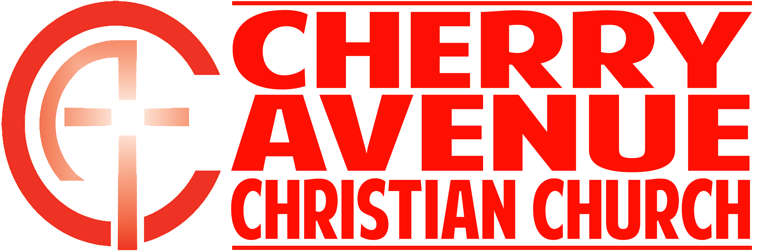
“When God Says No”
2 Corinthians 12:7b-10

God’s lack of ___________________ is not an argument for or against His __________________.

“Therefore, in order to keep me from becoming conceited, I was given a thorn in my flesh, a messenger of Satan, to torment me. ⁸ Three times I pleaded with the Lord to take it away from me. ⁹ But he said to me, “My grace is sufficient for you, for my power is made perfect in weakness.” Therefore I will boast all the more gladly about my weaknesses, so that Christ’s power may rest on me. ¹⁰ That is why, for Christ’s sake, I delight in weaknesses, in insults, in hardships, in persecutions, in difficulties. For when I am weak, then I am strong.” 2 Corinthians 12:7b-10 (TNIV)

God will leverage His ______________ in our ____________ if we learn to take __________ for an answer.

Implications of this passage:
- We have permission to ask God to _____________ our ____________.

- God has permission to say, __________.

- God may choose to showcase His ____________ in our _____________.

- We can’t experience God’s sustaining ____________ while resisting His ___________.

