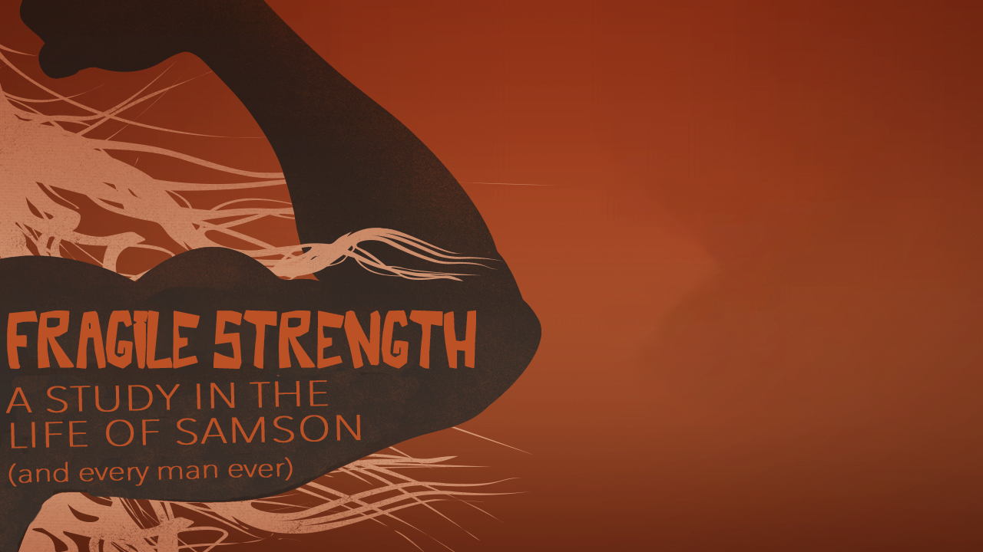
Attitude Adjustment
Fragile Strength, part one
Judges 13-14

“I looked for someone among them who would build up the wall and stand before me in the gap on behalf of the land so I would not have to destroy it, but I found no one.”
Ezekiel 22:30 (NIV)

“Again the Israelites did evil in the eyes of the Lord, so the Lord delivered them into the hands of the Philistines for forty years.” Judges 13:1 (NIV)

“You will become pregnant and have a son whose head is never to be touched by a razor because the boy is to be a Nazirite, dedicated to God from the womb. He will take the lead in delivering Israel from the hands of the Philistines.” Judges 13:5 (NIV)

Three vows Samson had to live by:
No ______________
Don’t touch anything that’s ______________
Don’t get your ____________ cut.

“He grew and the Lord blessed him, ²⁵ and the Spirit of the Lord began to stir him.” Judges 13:24-25 (NIV)

Attitudes that make our strength fragile:
___________

“Samson went down to Timnah and saw there a young Philistine woman. ² When he returned, he said to his father and mother, “I have seen a Philistine woman in Timnah; now get her for me as my wife.” Judges 14:1-2 (NIV)

_______________

“He turned aside to look at the lion’s carcass, and in it he saw a swarm of bees and some honey. ⁹ He scooped out the honey with his hands and ate as he went along.” Judges 14:8-9 (NIV)

______________

“Now his father went down to see the woman. And there Samson held a feast, as was customary.” Judges 14:10 (NIV)

You can only know God’s ____________ when you admit your _____________.

“My strength is made perfect in weakness.”
2 Corinthians 12:9 (KJV)

“That is why, for Christ’s sake, I delight in weakness…. For when I am weak, then I am strong.” 2 Corinthians 12:10 (NIV)

