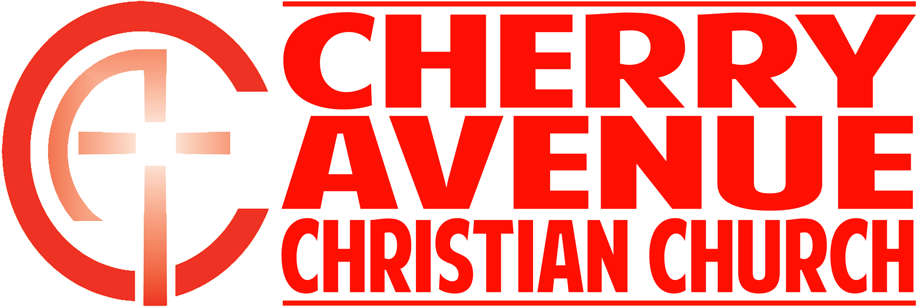
“What Did You Bring?”
Romans 12:1

In our culture, we tend to come to worship with a __________ mentality: “What am I going to ______?”

In Scripture, people always ___________ something to _____ in worship.

“On the third day Abraham looked up and saw the place in the distance. ⁵ He said to his servants, “Stay here with the donkey while I and the boy go over there. We will worship and then we will come back to you.” ⁶ Abraham took the wood for the burnt offering and placed it on his son Isaac, and he himself carried the fire and the knife.”
Genesis 22:4-6 (NIV)

“Bring my sons from afar and my daughters from the ends of the earth—⁷ everyone who is called by my name, whom I created for my glory, whom I formed and made.” Isaiah 43:6-7 (NIV)

Worship is the ___________ and ____________ of ________.

“Therefore, “I urge you, brothers and sisters, in view of God’s mercy, to offer your bodies as a living sacrifice, holy and pleasing to God—this is your true and proper worship.” Romans 12:1 (NIV)

“So here’s what I want you to do, God helping you: Take your everyday, ordinary life—your sleeping, eating, going-to-work, and walking-around life—and place it before God as an offering.” Romans 12:1 (Msg.)

“They devoted themselves to the apostles’ teaching and to fellowship, to the breaking of bread and to prayer.” Acts 2:42 (NIV)

