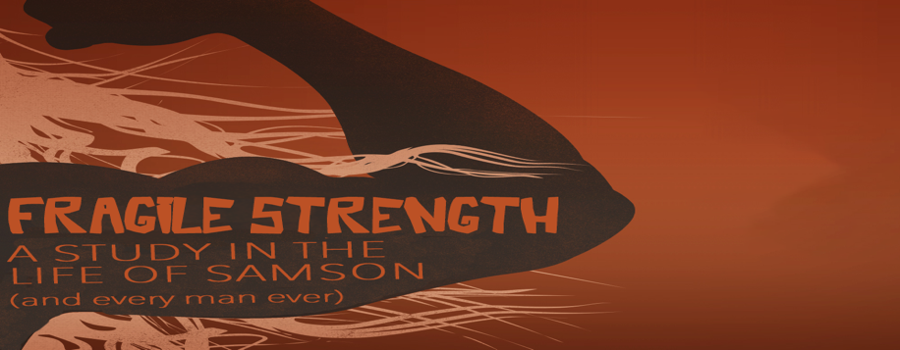
Emotion-Driven
Fragile Strength, part 2
Judges 14-15

“So I say, live by the Spirit, and you will not gratify the desires of the sinful nature. ¹⁷ [Because] the sinful nature desires what is contrary to the Spirit, and the Spirit what is contrary to the sinful nature. They are in conflict with each other, so that you do not do what you want.” Galatians 5:16-17 (NIV ’84)

Too often we’re _______________-driven, rather than ____________-led.

“Out of the eater, something to eat; out of the strong, something sweet.”
Judges 14:14 (NIV)

“Before sunset on the seventh day the men of the town said to him, ‘What is sweeter than honey? What is stronger than a lion?’ Samson said to them, ‘If you had not plowed with my heifer, you would not have solved my riddle….’ ¹⁹ He went down to Ashkelon, struck down thirty of their men, stripped them of everything and gave their clothes to those who had explained the riddle. Burning with anger, he returned to his father’s home. ²⁰ And Samson’s wife was given to one of his companions who had attended him at the feast.” Judges 14:18-20 (NIV)

Emotions that were controlling Samson:

______________ (v.19)

Too often we get angry at _____________ when our ____________ are to blame.

______________

¹⁵ Finding a fresh jawbone of a donkey, he grabbed it and struck down a thousand men. ¹⁶ Then Samson said, “With a donkey’s jawbone I have made donkeys of them. With a donkey’s jawbone I have killed a thousand men.” Judges 15:15-16 (NIV)

If you let you need drive you to _________, God will meet your deepest __________.

^{18 “}Because he was very thirsty, he cried out to the Lord, ‘You have given your servant this great victory. Must I now die of thirst and fall into the hands of the uncircumcised?’ ¹⁹ Then God opened up the hollow place in Lehi, and water came out of it. When Samson drank, his strength returned and he revived.” Judges 15:18-19 (NIV)

