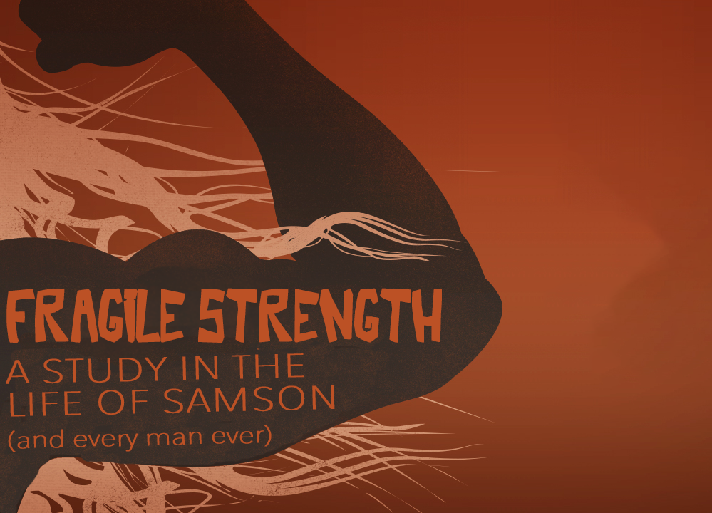
One Step at a Time
Fragile Strength, part three
Judges 16

“Samson led Israel for twenty years in the days of the Philistines.” Judges 15:20 (NIV)

What brought Samson down was ____________.

“One day Samson went to Gaza, where he saw a prostitute. He went in to spend the night with her. ² The people of Gaza were told, ‘Samson is here!’ So they surrounded the place and lay in wait for him all night at the city gate. They made no move during the night, saying, ‘At dawn we’ll kill him.’” Judges 16:1-2 (NIV)

“One evening David got up from his bed and walked around on the roof of the palace. From the roof he saw a woman bathing. The woman was very beautiful, ³ and David sent someone to find out about her.” 2 Samuel 11:2-3 (NIV)

Samson _____________ with _________________.

³ “But Samson lay there only until the middle of the night. Then he got up and took hold of the doors of the city gate, together with the two posts, and tore them loose, bar and all. He lifted them to his shoulders and carried them to the top of the hill that faces Hebron.” Judges 16:3 (NIV)

“Your enemy the devil prowls around like a roaring lion, looking for someone to devour.” 1 Peter 5:8 (NIV)

“So, if you think you are standing firm, be careful that you don’t fall!”
1 Corinthians 10:12 (NIV)

Samson ______________ his ________.

“Some time later, he fell in love with a woman in the Valley of Sorek whose name was Delilah. ⁵ The rulers of the Philistines went to her and said, ‘See if you can lure him into showing you the secret of his great strength and how we can overpower him so we may tie him up and subdue him.’” Judges 16:4-5 (NIV)

“Then she said to him, ‘How can you say, ‘I love you,’ when you won’t confide in me? This is the third time you have made a fool of me and haven’t told me the secret of your great strength.’ ¹⁶ With such nagging she prodded him day after day until he was sick to death of it.
¹⁷ So he told her everything. ‘No razor has ever been used on my head,’ he said, ‘because I have been a Nazirite dedicated to God from my mother’s womb. If my head were shaved, my strength would leave me, and I would become as weak as any other man….’
¹⁹ After putting him to sleep on her lap, she called for someone to shave off the seven braids of his hair, and so began to subdue him. And his strength left him.” Judges 16:15-19 (NIV)

Samson assumed _______________ didn’t _____________.

²⁰ “Then she called, ‘Samson, the Philistines are upon you!’ He awoke from his sleep and thought, ‘I’ll go out as before and shake myself free.’ But he did not know that the Lord had left him. ²¹ Then the Philistines seized him, gouged out his eyes and took him down to Gaza. Binding him with bronze shackles, they set him to grinding grain in the prison. ²² But the hair on his head began to grow again after it had been shaved.”
Judges 16:20-22 (NIV)

