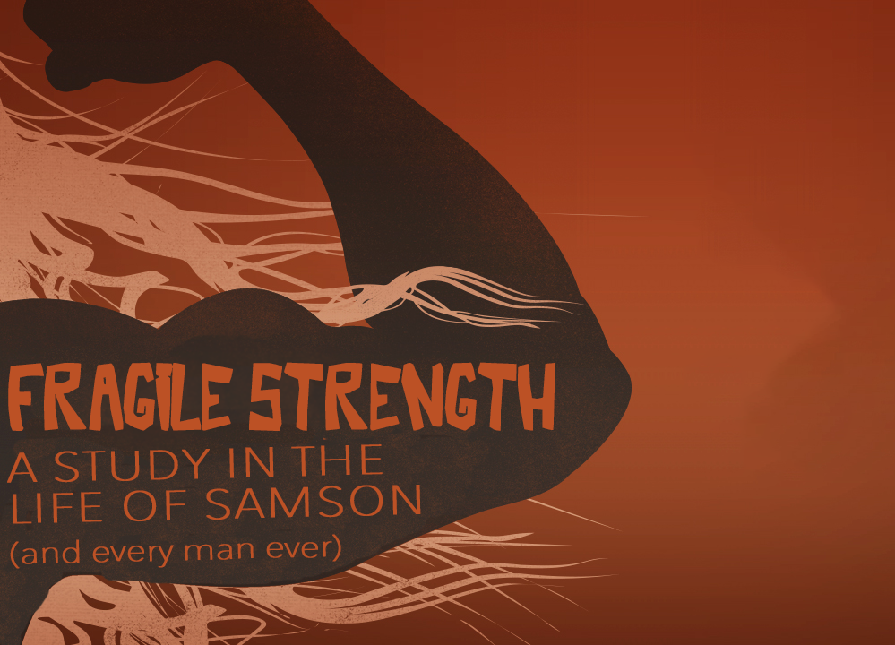
Finishing Strong
Fragile Strength, part four
Judges 16:21-30

²¹ Then the Philistines seized him, gouged out his eyes and took him down to Gaza. Binding him with bronze shackles, they set him to grinding grain in the prison. ²² But the hair on his head began to grow again after it had been shaved.
²³ Now the rulers of the Philistines assembled to offer a great sacrifice to Dagon their god and to celebrate, saying, “Our god has delivered Samson, our enemy, into our hands.”
²⁴ When the people saw him, they praised their god, saying, “Our god has delivered our enemy into our hands, the one who laid waste our land and multiplied our slain.”
²⁵ While they were in high spirits, they shouted, “Bring out Samson to entertain us.” So they called Samson out of the prison, and he performed for them.
When they stood him among the pillars, ²⁶ Samson said to the servant who held his hand, “Put me where I can feel the pillars that support the temple, so that I may lean against them….”
²⁸ Then Samson prayed to the Lord, “Sovereign Lord, remember me. Please, God, strengthen me just once more, and let me with one blow get revenge on the Philistines for my two eyes.” ²⁹ Then Samson reached toward the two central pillars on which the temple stood. Bracing himself against them, his right hand on the one and his left hand on the other, ³⁰ Samson said, “Let me die with the Philistines!” Then he pushed with all his might, and down came the temple on the rulers and all the people in it. Thus he killed many more when he died than while he lived. Judges 16:21-26, 27-30 (NIV)

A failure is an _____________, not a ______________. (v.22)

There are two responses to failure: _________________ and _________________.

If you want to finish strong, even after failure, ________________.

If you want to finish strong, even after failure, live for _________ __________, not your own _______________.

“Do not take revenge, my dear friends, but leave room for God’s wrath, for it is written: “It is mine to avenge; I will repay,” says the Lord.” Romans 12:19 (NIV)

God can use even our _____________ to accomplish His _____________. (v.30)

“Though a righteous man falls seven times, he will get up.” Proverbs 24:16 (HCSB)

