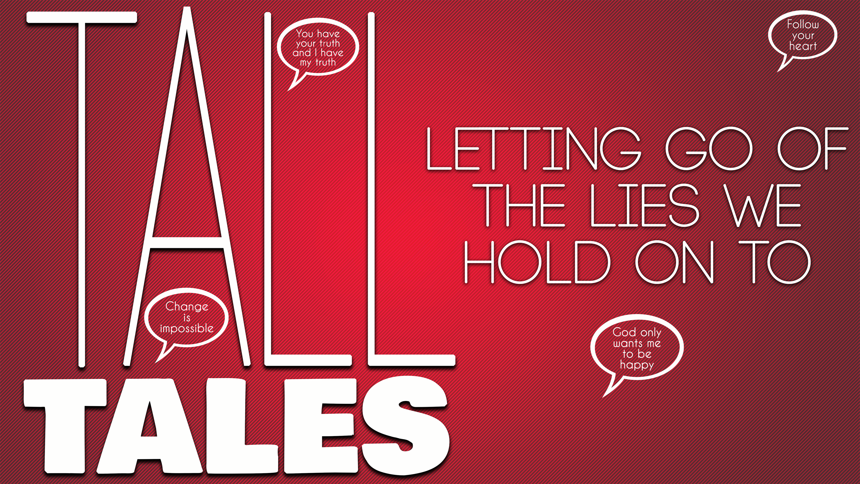
You’ll Never Change
Tall Tales, part one
Romans 12:2

“There is no truth in him. When he lies, he speaks his native language, for he is a liar and the father of lies.” John 8:44 (NIV)

“Let us examine our ways and test them, and let us return to the Lord.”
Lamentations 3:40 (NIV)

“If you hold to my teaching, you are really my disciples.³² Then you will know the truth, and the truth will set you free.” John 8:31-32 (NIV)

Stronghold: “________ of the enemy that we _________ by”

“I want to do what is right, but I can’t.¹⁹ I want to do what is good, but I don’t. I don’t want to do what is wrong, but I do it anyway.” Romans 7:18 (NLT)

“I have the desire to do what is good, but I cannot carry it out” (NIV).

“For though we live in the world, we do not wage war as the world does. ⁴ The weapons we fight with are not the weapons of the world. On the contrary, they have divine power to demolish strongholds. ⁵ We demolish arguments and every pretension that sets itself up against the knowledge of God, and we take captive every thought to make it obedient to Christ.” 2 Corinthians 10:3-5 (NIV)

The Law of Cognition: “You ______ what you _________ about.”

“Be careful how you think; your life is shaped by your thoughts.” Proverbs 4:23 (GNT)

The Law of Exposure: “Your mind ____________ and _____________ whatever it’s _____________ to the ___________.”

“Those who are dominated by the sinful nature think about sinful things, but those who are controlled by the Holy Spirit think about things that please the Spirit. ⁶ So letting your sinful nature control your mind leads to death. But letting the Spirit control your mind leads to life and peace.” Romans 8:5-6 (NLT)

“Do not conform to the pattern of this world, but be transformed by the renewing of your mind.” Romans 12:2 (NIV)

“Let God transform you… by changing the way you think.” (NLT).

Thoughts to counter this lie:

“______________, not _______________”

“I am certain that God, who began the good work within you, will continue his work until it is finally finished on the day when Christ Jesus returns.” Philippians 1:6 (NLT)

“_________ power, not _____ power”

“I … pray that you will understand the incredible greatness of God’s power for us who believe him. This is the same mighty power²⁰ that raised Christ from the dead.” Ephesians 1:19-20 (NLT)

