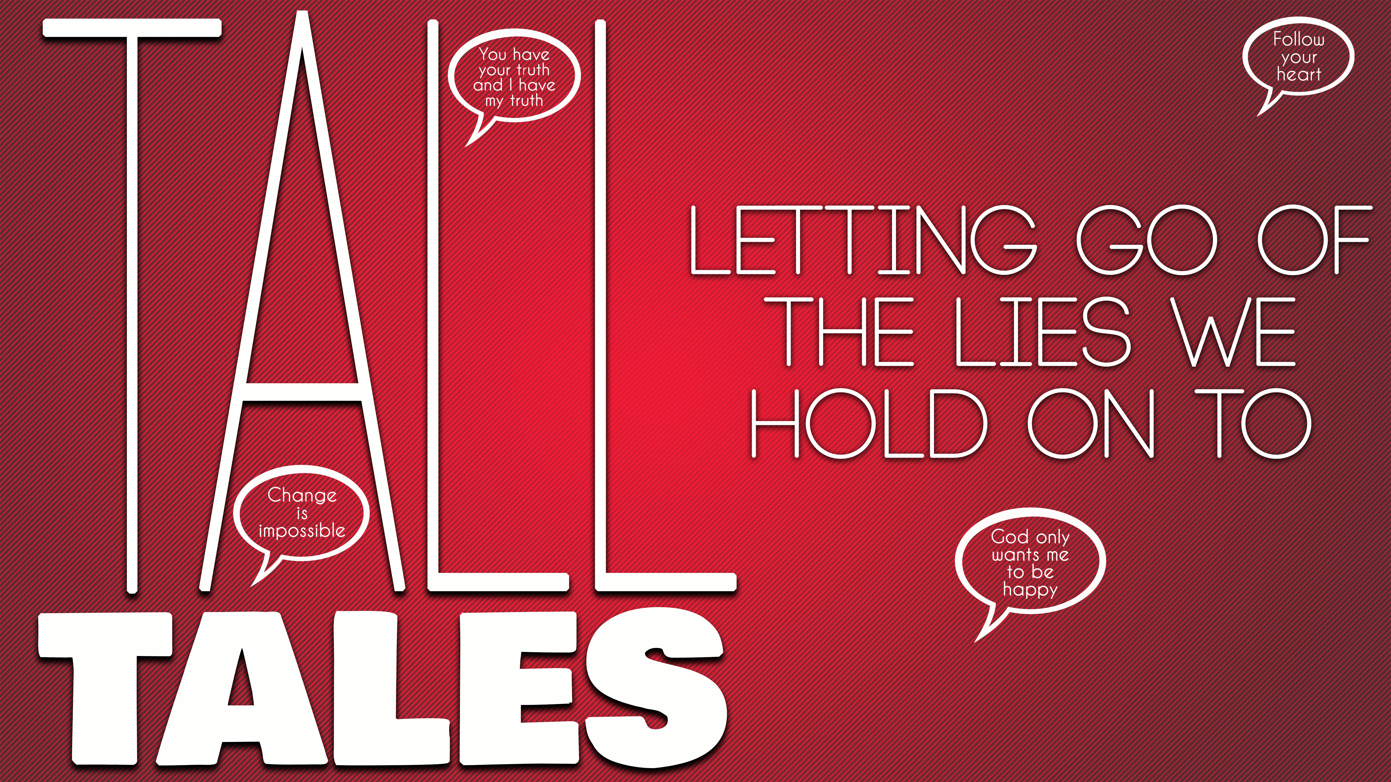
Let Your Conscience Be Your Guide
Tall Tales, part five

Your conscience is a spiritual _________________, not a ____________________. It reflects our _______________ of right and wrong.

Our conscience doesn’t tell us when we’re violating _________ standards, it tells us when we’re violating __________. (1 Corinthians 4:3-4)

Why can’t we trust our conscience alone?
Because we have a natural bent toward _______.

“Therefore, just as sin entered the world through one man, and death through sin, and in this way death came to all men, because all sinned…” Romans 5:12 (NIV ’84)

Like a computer, our conscience is only as accurate as the __________ it relies on.

“There is a way that seems right to a man, but in the end it leads to death.”
Proverbs 14:12 (NIV ’84)

It can become __________________.

“To the pure, all things are pure, but to those who are corrupted and do not believe, nothing is pure. In fact, both their minds and consciences are corrupted.” Titus 1:15 (NIV ’84)

Our conscience isn’t meant to be a guide, but an _________ _____________ ________________.

Our conscience can be recalibrated _________________.

How to recalibrate your conscience:
__________ your ________ to ___________.

“How much more, then, will the blood of Christ, who through the eternal Spirit offered himself unblemished to God, cleanse our consciences from acts that lead to death, so that we may serve the living God!” Hebrews 9:13-14 (NIV ’84) Also 1 Peter 1:21

- Make ______ standards _________ standards.

“How can a young man keep his way pure? By living according to your word. I seek you with all my heart; do not let me stray from your commands. I have hidden your word in my heart that I might not sin against you.” Psalm 119:9-11 (NIV ’84)

