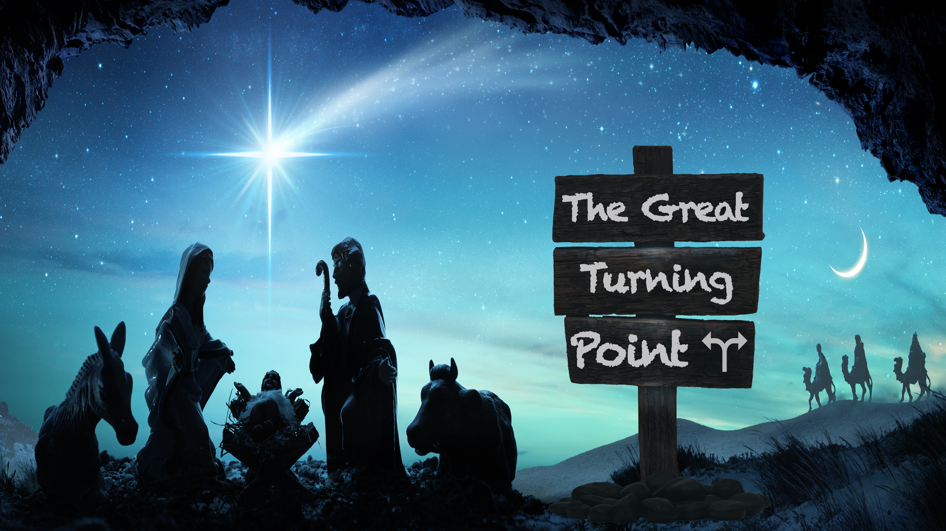
“Bondage Gives Way to Freedom”
“The Great Turning Point,” part two
Deuteronomy 18, Luke 4

“I will raise up for them a prophet like you from among their fellow Israelites, and I will put my words in his mouth. He will tell them everything I command him. ¹⁹ I myself will call to account anyone who does not listen to my words that the prophet speaks in my name.” Deuteronomy 18:18-19 (NIV)

“Are you the prophet we are expecting?” John 1:21 (NLT)

“’The Spirit of the Lord is upon me, for he has anointed me to bring Good News to the poor. He has sent me to proclaim that captives will be released, that the blind will see, that the oppressed will be set free, ¹⁹ and that the time of the Lord’s favor has come.’ ²⁰ He rolled up the scroll, handed it back to the attendant, and sat down. All eyes in the synagogue looked at him intently…. ^{21 ‘}The Scripture you’ve just heard has been fulfilled this very day!’” Luke 4:18-21 (NLT)

[Jesus came,] “freeing you from a fated lifetime of brutal tyranny at the hands of sin and death.” Romans 8:2 (Msg.)

Signs of our bondage to sin:

When we _________ in it, despite the _________ _________.

When trying to ______ feels ___________.

“Once you were slaves of sin, but now you wholeheartedly obey this teaching we have given you.” Romans 6:17 (NLT)

“Now you are no longer a slave but God’s own child.” Galatians 4:7 (NLT)

When keeping it _________ is your _________.

When you try to deal with it by __________ it _________.

“What have you done to us? Why did you make us leave Egypt? ¹² Didn’t we tell you this would happen while we were still in Egypt? We said, ‘Leave us alone! Let us be slaves to the Egyptians.” Exodus 14:11-12 (NLT)

“’I am the Lord. I will free you from your oppression and will rescue you from your slavery in Egypt….’ ⁹ So Moses told the people of Israel what the Lord had said, but they refused to listen anymore. They had become too discouraged by the brutality of their slavery.’” Exodus 6:6,9 (NLT)

“They didn’t even hear him because their spirits were beaten down by their harsh slave conditions.” Exodus 6:9 (Msg.)

“His life brought light to everyone. ⁵ The light shines in the darkness, and the darkness can never extinguish it.” John 1:4-5 (NIV)

“[God] sent Me to tell those who are held captive that they can now be set free.”
Luke 4:18 (Voice)

