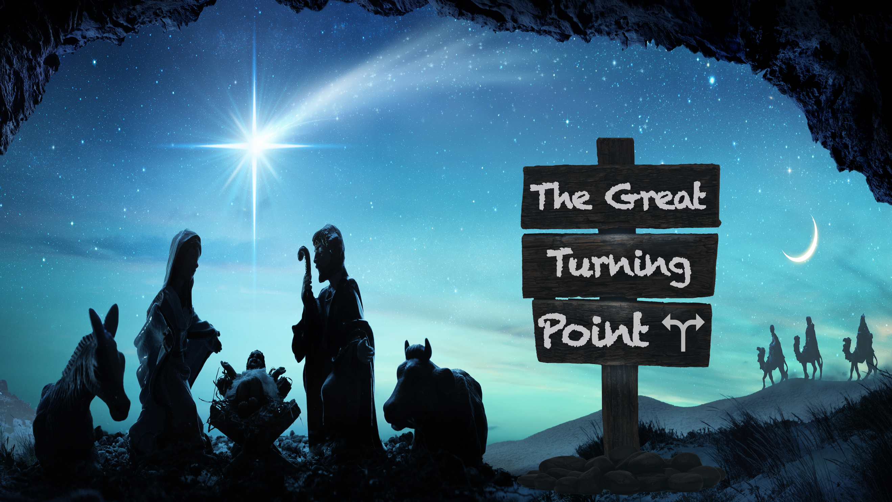
Sin Gives Way to a Savior
The Great Turning Point, part one
Genesis 3

“But you must not eat from the tree of the knowledge of good and evil, for when you eat from it you will certainly die.” Genesis 2:17 (NIV)

“Now the serpent was more crafty than any of the wild animals the Lord God had made. He said to the woman, ‘Did God really say, ‘You must not eat from any tree in the garden’? ⁴ You will not certainly die,… ⁵For God knows that when you eat from it your eyes will be opened, and you will be like God, knowing good and evil.’”
Genesis 3:1,4-5 (NIV)

Satan’s tactics:
He ____________ God’s _________. (v.1)

He ____________ God. (v.4)

He _______________ what God says. (v.5)

“When the woman saw that the fruit of the tree was good for food and pleasing to the eye, and also desirable for gaining wisdom, she took some and ate it. She also gave some to her husband, who was with her, and he ate it.” Genesis 3:6 (NIV)

Consequences of sin:

It ________________ us from God.

“Then the eyes of both of them were opened, and they realized they were naked; so they sewed fig leaves together and made coverings for themselves. Then the man and his wife heard the sound of the Lord God as he was walking in the garden in the cool of the day, and they hid from the Lord God among the trees of the garden.”
Genesis 3:7-8 (NIV)

It __________ our __________________.

“And he said, ‘Who told you that you were naked? Have you eaten from the tree that I commanded you not to eat from?’ ¹² The man said, ‘The woman you put here with me—she gave me some fruit from the tree, and I ate it.’” Genesis 3:11-12 (NIV)

________________

“To the woman he said, ‘I will make your pains in childbearing very severe; with painful labor you will give birth to children…. ¹⁷ To Adam he said, ‘Because you listened to your wife and ate fruit from the tree about which I commanded you, ‘You must not eat from it,’ Cursed is the ground because of you; through painful toil you will eat food from it all the days of your life.’” Genesis 3:16-17 (NIV)

“And I will put enmity between you and the woman, and between your offspring and hers; he will crush your head, and you will strike his heel.” Genesis 3:15 (NIV)

“Joseph son of David, do not be afraid to take Mary home as your wife, because what is conceived in her is from the Holy Spirit. ²¹ She will give birth to a son, and you are to give him the name Jesus, because he will save his people from their sins.”
Matthew 1:20-21 (NIV)

“Salvation is found in no one else, for there is no other name under heaven given to mankind by which we must be saved.” Acts 4:12 (NIV)

Before Christmas, _______ reigned, but Christmas brought a _____________.

“The Lord God made garments of skin for Adam and his wife and clothed them.”
Genesis 3:21 (NIV)

“Without the shedding of blood there is no forgiveness of sin.” Hebrews 9:22 (NIV ’84)

