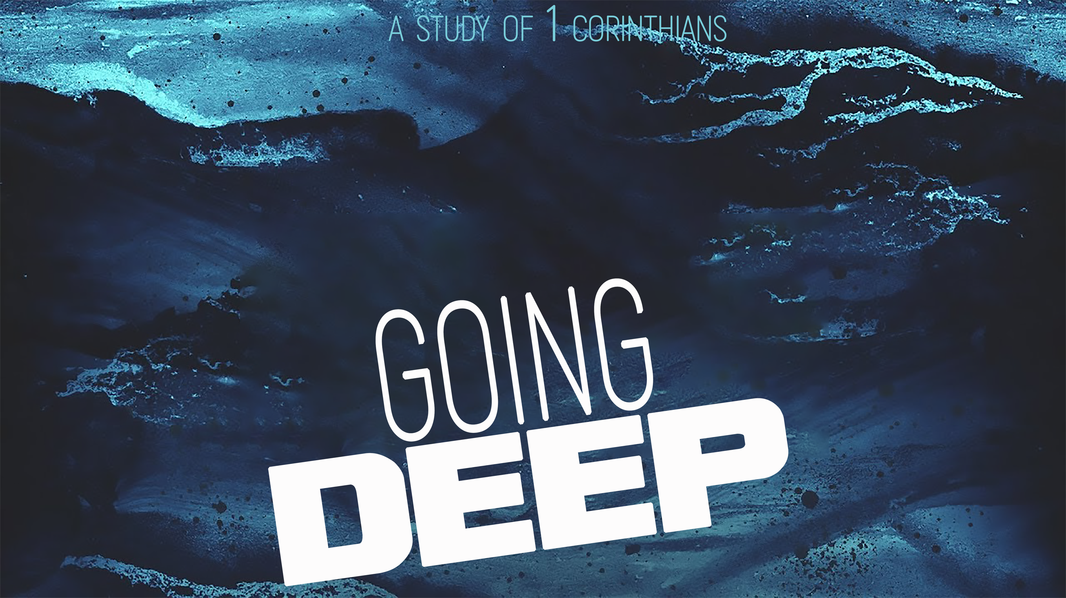
Embracing Spiritual Freedom
“Going Deep,” part three
1 Corinthians 8-10

We have to balance _____________ with ________.

“Knowledge puffs up while love builds up.”
1 Corinthians 8:1 (NIV)

“The law was given through Moses; grace and truth came through Jesus Christ.”
John 1:17 (NIV)

“Be careful, however, that the exercise of your freedom does not become a stumbling block to the weak.” 1 Corinthians 8:9 (NIV ’84)

We should love ___________ more than our ___________.

“To the weak I became weak, to win the weak. I have become all things to all men so that by all possible means I might save some. ²³ I do all this for the sake of the gospel, that I may share in its blessings.” 1 Corinthians 9:22-23 (NIV ’84)

Our responsibility is to ___________ people to _______ and _____ _________.

“So if you think you’re standing firm, be careful that you don’t fall.”
1 Corinthians 10:12 (NIV ’84)

“So whether you eat or drink or whatever you do, do it all for the glory of God.”
1 Corinthians 10:31 (NIV ’84)

Whatever you decide to do, be certain you can do it for the _______ of _____.

Questions to consider regarding exercising your freedom:

- Will my behavior lead me to ___________ or ___________?

- Will this decision be a ___________ ________ or a ________ ________ for others?

“If what I eat causes my brother to fall into sin, I will never eat meat again, so that I will not cause him to fall.” 1 Corinthians 8:13 (NIV)

- Will these actions only gratify ______ or glorify __________?

- Will my choices help ______ lost people to Christ or _______ them ________?

