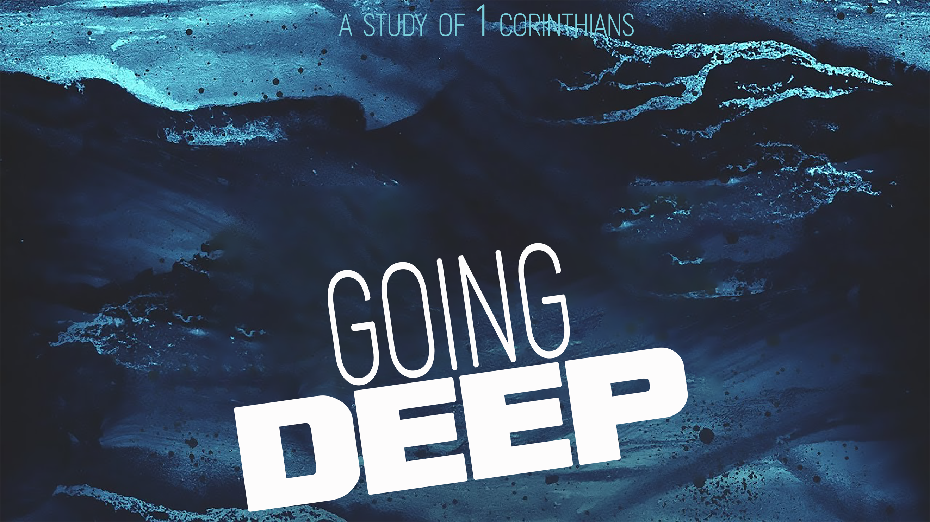
Living with an Eternal Perspective
Going Deep, part nine
1 Corinthians 15

Our faith is based on an _________—the _____________ of Jesus.

“If there is no resurrection of the dead, then not even Christ has been raised. ¹⁴ And if Christ has not been raised, our preaching is useless and so is your faith…. ¹⁶ For if the dead are not raised, then Christ has not been raised either. ¹⁷ And if Christ has not been raised, your faith is futile; you are still in your sins. ¹⁸ Then those also who have fallen asleep in Christ are lost. ¹⁹ If only for this life we have hope in Christ, we are to be pitied more than all men.” 1 Corinthians 15:13-14, 16-19 (NIV ‘84)

“But Christ has indeed been raised from the dead.” 1 Corinthians 15:20 (NIV ‘84)

“But Christ has indeed been raised from the dead, the firstfruits of those who have fallen asleep. For since death came through a man, the resurrection of the dead comes also through a man. For as in Adam all die, so in Christ all will be made alive.”
1 Corinthians 15:20-22 (NIV ‘84)

“’Death has been swallowed up in victory.’ ⁵⁵ Where, O death, is your victory? Where, O death, is your sting?” ⁵⁶ The sting of death is sin, and the power of sin is the law. ⁵⁷ But thanks be to God! He gives us the victory through our Lord Jesus Christ.”
1 Corinthians 15:54-57 (NIV ‘84)

“Therefore, my dear brothers, stand firm. Let nothing move you. Always give yourselves fully to the work of the Lord, because you know that your labor in the Lord is not in vain.” 1 Corinthians 15:58 (NIV ’84)

Live with an __________ _____________.

“If the dead are not raised, ‘Let us eat and drink, for tomorrow we die.’”
1 Corinthians 15:32 (NIV ’84)

Make your closest friends those who _________ your __________.

“Do not be mislead; ‘Bad company corrupts good character.’”
1 Corinthians 15:33 (NIV ’84)

Focus on ____________ _____________.

“We are God’s masterpiece. He has created us anew in Christ Jesus, so we can do the good things he planned for us long ago.” Ephesians 2:10 (NLT)

“Whoever sows to please the Spirit, from the Spirit will reap eternal life. ⁹ Let us not become weary in doing good, for at the proper time we will reap a harvest if we do not give up. ¹⁰ Therefore, as we have opportunity, let us do good to all people, especially to those who belong to the family of believers.” Galatians 6:8-10 (NIV)

