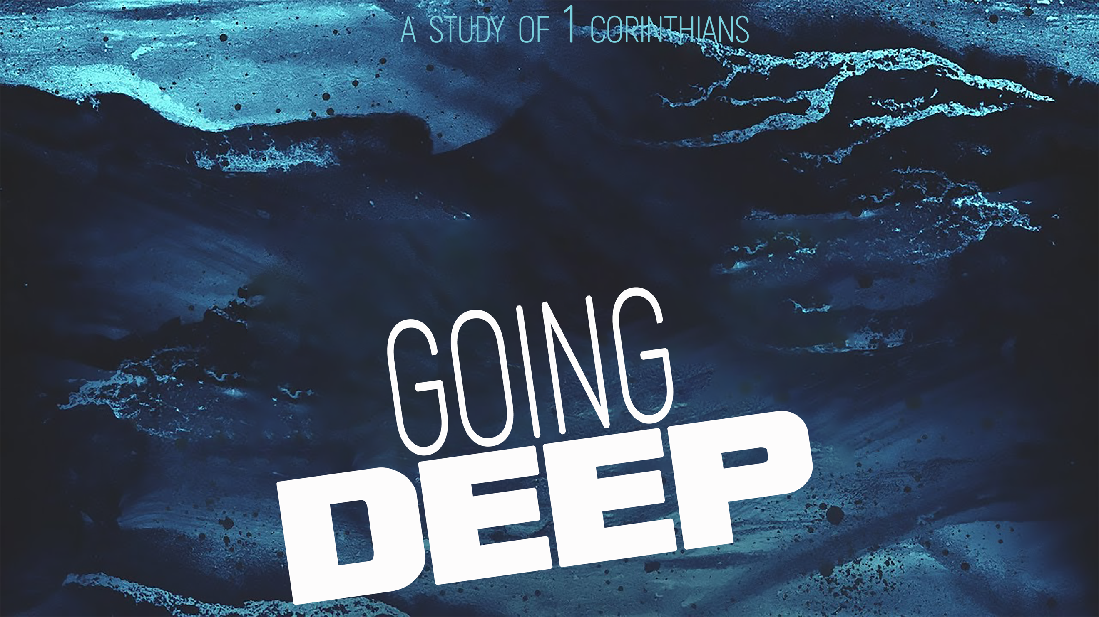
The Challenge
“Going Deep,” part ten
1 Corinthians 16

Be ____________.

“Now about the collection for the Lord’s people: Do what I told the Galatian churches to do. ² On the first day of every week, each one of you should set aside a sum of money in keeping with your income, saving it up, so that when I come no collections will have to be made.” 1 Corinthians 16:1-2 (NIV)

Principles of Generosity:

Generosity is for __________ (“Each of you”).

Make giving a __________ ___________ (“on the first day of every week”).

“Last year you were the first not only to give but also to have the desire to do so. ¹¹ Now finish the work, so that your eager willingness to do it may be matched by your completion of it, according to your means.” 2 Corinthians 8:10b-11 (NIV)

____________ your giving (“set aside”).

Make your giving ___________ to your __________ (“a sum in keeping with your income”).

“Each of you should give what you have decided in your heart to give, not reluctantly or under compulsion, for God loves a cheerful giver. ⁸ And God is able to bless you abundantly, so that in all things at all times, having all that you need, you will abound in every good work. ⁹ As it is written: ‘They have freely scattered their gifts to the poor; their righteousness endures forever.’” 2 Corinthians 9:7-9 (NIV)

“Be on your guard; stand firm in the faith; be courageous; be strong.
¹⁴ Do everything in love.” 1 Corinthians 16:13-14 (NIV)

Be on ____________.

“Be alert and of sober mind. Your enemy the devil prowls around like a roaring lion looking for someone to devour.” 1 Peter 5:8 (NIV)

“So, if you think you are standing firm, be careful that you don’t fall!”
1 Corinthians 10:12 (NIV)

_________ _________ in your faith.

“Stand firm. Let nothing move you.” 1 Corinthians 15:58 (NIV)

Be _____________.

“In this world you will have trouble. But take heart! I have overcome the world.”
John 16:33 (NIV)

Be ___________.

“The Lord is the everlasting God, the Creator of the ends of the earth. He will not grow tired or weary…. ²⁹ He gives strength to the weary and increases the power of the weak.” Isaiah 40:28-29 (NIV)

Do everything in _________.

“Love your enemies and pray for those who persecute you, that you may be children of your Father in heaven.” Matthew 5:44-45 (NIV)

