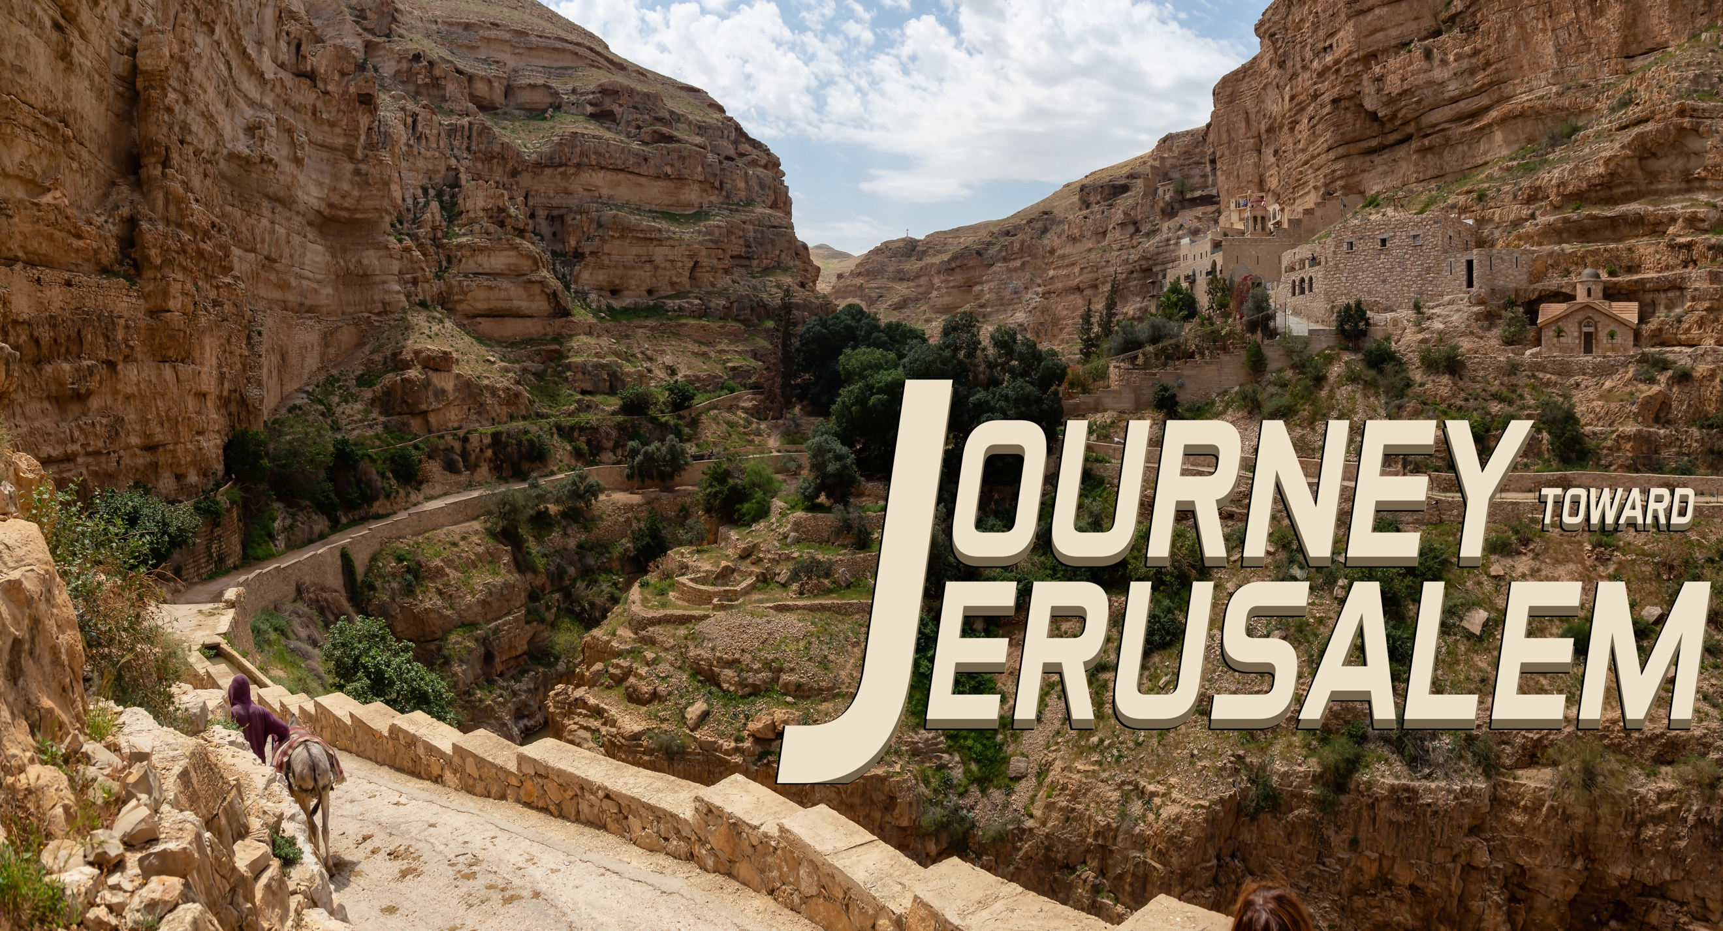
“A Journey Toward Jerusalem”
Matthew 21: 1 – 11

Palm Sunday is significant for this would be the last time Jesus enters
His Holy City Jerusalem, the last week He’d spend in His City of Peace.

His Entry ________________________________________________

¹⁰ When Jesus entered Jerusalem, the whole city was stirred and asked, “Who is this?”
¹¹ The crowds answered, “This is Jesus, the prophet from Nazareth in Galilee.

His Entry ________________________________________________

⁴ This took place to fulfill what was spoken through the prophet: ⁵ “Say to Daughter Zion,
‘See, your king comes to you, gentle and riding on a donkey, and on a colt, the foal of a donkey.’”

His Entry ________________________________________________

⁸ A very large crowd spread their cloaks on the road, while others cut branches from the tree
and spread them on the road.

His Entry ________________________________________________

⁹ The crowds that went ahead of him and those that followed shouted, “Hosanna to the Son of David!” “Blessed is he who comes in the name of the Lord!” “Hosanna in the highest heaven!”

