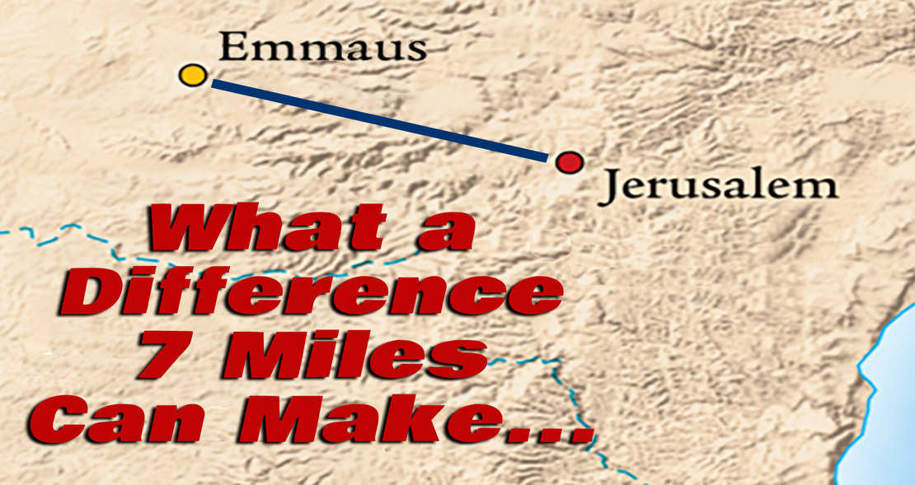

The________________________ of the two men
Luke 24: 13
Now that same day two of them were going to a village called Emmaus,
about seven miles from Jerusalem.

Luke 24: 15 – 16
As they talked and discussed these things with each other, Jesus himself came up and walked along with them; but they were kept from recognizing him.

The_______________________ of the two men
Luke 24: 28 – 29
As they approached the village to which they were going, Jesus continued on as if he were going farther. But they urged him strongly, “Stay with us, for it is nearly evening; the day is almost over.” So he went in to stay with them.

The _____________________ of the two men
Luke 24: 30 – 32
When he was at the table with them, he took bread, gave thanks, broke it and began to give it to them. Then their eyes were opened and they recognized him, and he disappeared from their sight.
They asked each other, “Were not our hearts burning within us while he talked with us on the road and opened the Scriptures to us?”

Luke 24: 33 – 35
They got up and returned at once to Jerusalem. There they found the Eleven and those with them, assembled together and saying, “It is true! The Lord has risen and has appeared to Simon.” Then the two told what had happened on the way, and how Jesus was recognized by them when he broke the bread.

