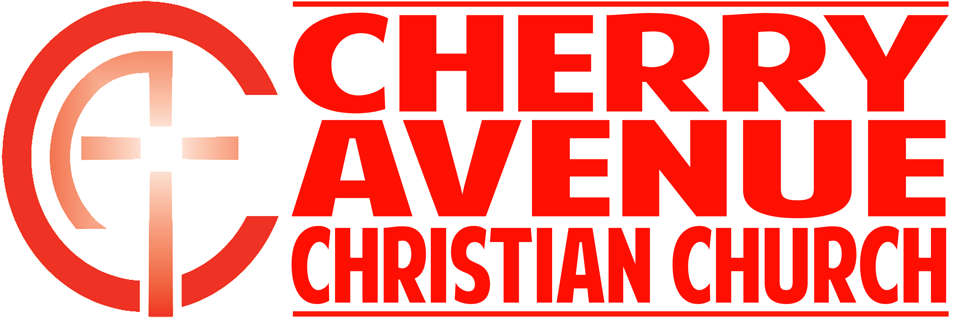
Navigating the Pressures of Fatherhood
Genesis 25-33; Ephesians 6:4

Some of the pressures Dads have to navigate:

Our own ________________

“A man’s wisdom gives him patience. It is to his glory to overlook an offense.”
Proverbs 19:11 (NIV)

______________ for our _______________

"Jacob grew exceedingly prosperous and came to own large flocks, and maidservants and menservants, and camels and donkeys.” Genesis 30:43 (NIV)

“I have heard that there is grain in Egypt. Go down there and buy some for us, so that we may live and not die.” Genesis 42:2 (NIV)

Being a ___________ ____________

Being a positive ____________ on our ______________

“Fathers, do not provoke your children to anger, but bring them up in the discipline and instruction of the Lord.” Ephesians 6:4 (NASB)

Two primary instructions God gives parents:

________________ them.

___________ them to ____________ God.

