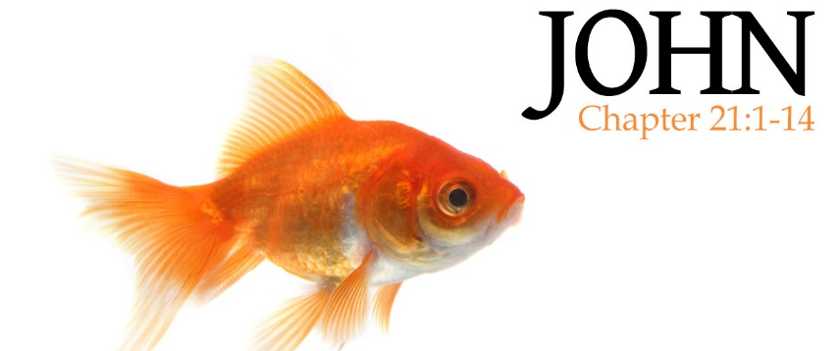
“a fish story …”

BE _________________________________________________________

John 21: 1
Afterward Jesus appeared again to his disciples, by the Sea of Galilee.

Matthew 28: 10
Go and tell my brothers to go to Galilee; there they will see me.

______________________________________________________________________________
______________________________________________________________________________

BE _________________________________________________________

John 21: 2 – 3
Simon Peter, Thomas (also known as Didymus), Nathanael from Cana in Galilee, the sons of Zebedee, and two other disciples were together.
“I’m going out to fish,” Simon Peter told them, and they said,
“We’ll go with you.” So they went out and got into the boat, but that night they caught nothing.

______________________________________________________________________________
______________________________________________________________________________

John 15: 4 – 5

BE _________________________________________________________

John 21: 4 – 6
Early in the morning, Jesus stood on the shore, but the disciples did not realize that it was Jesus. He called out to them, “Friends, haven’t you any fish?” “No,” they answered. [Jesus] said, “Throw your net on the right side of the boat and you will find some.” When they did, they were unable to haul the net in because of the large number of fish.

______________________________________________________________________________
______________________________________________________________________________
Proverbs 3: 5 – 6 Psalm 37: 4

BE _________________________________________________________

John 21: 7 – 9 & 12 – 13
⁷ Then the disciple whom Jesus loved said to Peter, “It is the Lord!”
As soon as Simon Peter heard him say, “It is the Lord,” he wrapped his outer garment around him … and jumped into the water.

⁸ The other disciples followed in the boat, towing the net full of fish,
⁹ When they landed, they saw a fire of burning coals there with fish on it, and some bread.

¹² Jesus said to them, “Come and have breakfast.” ¹³ Jesus came, took the bread and gave it to them, and did the same with the fish.

______________________________________________________________________________
______________________________________________________________________________
EVERYTHING CHANGES WHEN …

______________________________ ______________________________

