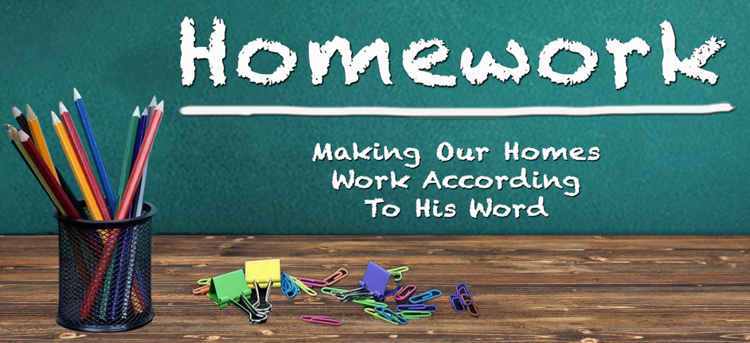
May 28th, 2023

“Home Sweet Home” II Samuel 6: 1 – 12

¹ David again brought together all the able young men of Israel—30,000.
² He and all his men went to Baalah in Judah to bring up from there the ark
of God, which is called by the Name, the name of the Lord Almighty,
who is enthroned between the cherubim on the ark.
³ They set the ark of God on a new cart and brought it from the house of Abinadab, which was on the hill. Uzzah and Ahio, sons of Abinadab, were guiding the new cart ⁴ with the ark of God on it, and Ahio was walking in front of it. ⁵ David and all Israel were celebrating with all their might before the Lord, with castanets, harps, lyres, tambourines, sistrums and cymbals. ⁶ When they came to the threshing floor of Nakon, Uzzah reached out and took hold of the ark of God, because the oxen stumbled.

⁷The Lord’s anger burned against Uzzah because of his irreverent act; therefore God struck him down, and he died there beside the ark of God.

⁸ Then David was angry because the Lord’s wrath had broken out against Uzzah, and to this day that place is called Perez Uzzah. ⁹ David was afraid of the Lord that day and said, “How can the ark of the Lord ever come to me?” ¹⁰ He was not willing to take the ark of the Lord to be with him in the City of David. Instead, he took it to the house of Obed-Edom the Gittite.

¹¹ The ark of the Lord remained in the house of Obed-Edom the Gittite for three months, and the Lord blessed him and his entire household.

¹² Now King David was told, “The Lord has blessed the household of
Obed-Edom and everything he has, because of the ark of God.”
So David went to bring up the ark of God from the house of Obed-Edom
to the City of David with rejoicing.
Call On God To Be Your __________________________________
Psalm 127: 1
Unless the Lord builds the house, the builders labor in vain.
Unless the Lord watches over the city, the guards stand watch in vain.

______________________________________________________________________________

Proverbs 24: 3 – 4
By wisdom a house is built, and through understanding it is established; through knowledge its rooms are filled with rare and beautiful treasures.

______________________________________________________________________________

Call On God To Be Your __________________________________
¹⁰ He was not willing to take the ark of the Lord to be with him in the City
of David. Instead, he took it to the house of Obed-Edom the Gittite.

¹¹ The ark of the Lord remained in the house of Obed-Edom the Gittite for three months, and the Lord blessed him and his entire household.

¹² Now King David was told, “The Lord has blessed the household of
Obed-Edom and everything he has, because of the ark of God.”

______________________________________________________________________________
______________________________________________________________________________

Hebrews 9: 4
This ark contained the gold jar of manna, Aaron’s staff that had budded,
and the stone tablets of the covenant.

1) His _________________________________________________
2) His _________________________________________________
3) His _________________________________________________

