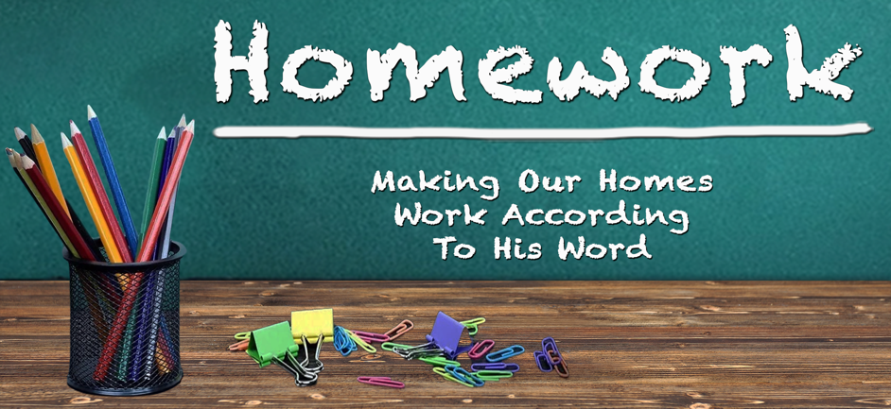
June 18th, 2023

“Being Men Of Influence” Various Scriptures

Psalm 127: 3 – 4

Children are a heritage from the Lord, offspring a reward from him.
Like arrows in the hands of a warrior are children born in one’s youth.

I___________________________________________________

Psalm 78: 72 David shepherded them with integrity of heart;
with skillful hands he led them.

K___________________________________________________

Ephesians 6: 18 … pray in the Spirit on all occasions
with all kinds of prayers and requests.

F___________________________________________________

Ephesians 4: 31 Be kind & compassionate to one another, forgiving each other, just as in Christ God forgave you.

Matt. 18: 21 – 22 Lord, how many times shall I forgive my brother or sister who sins against me? Up to 7 times?
Jesus answered … not 7 times, but 77 times.

L___________________________________________________

Ephesians 5: 25 Husbands, love your wives, just as Christ
loved the church & gave himself up for her …

U___________________________________________________

Proverbs 2: 6 For the Lord gives wisdom; from his mouth come knowledge and understanding.

E___________________________________________________

Romans 12: 11 Never be lacking in zeal, but keep your
spiritual fervor, serving the Lord.

N___________________________________________________

I Peter 2: 2 – 3 Like newborn babies, crave pure spiritual milk,
so that by it you may grow up in your salvation,
now that you have tasted that the Lord is good.
Great Quote:
“We are never too old to face new challenges, fight new battles,
and learn new truths. When we stop learning we stop growing.
When we stop growing we stop living.”

C___________________________________________________

Ephesians 4: 31 Be kind and compassionate to one another…

E___________________________________________________

I Cor. 11: 1 Follow my example, as I follow the example of Christ.

