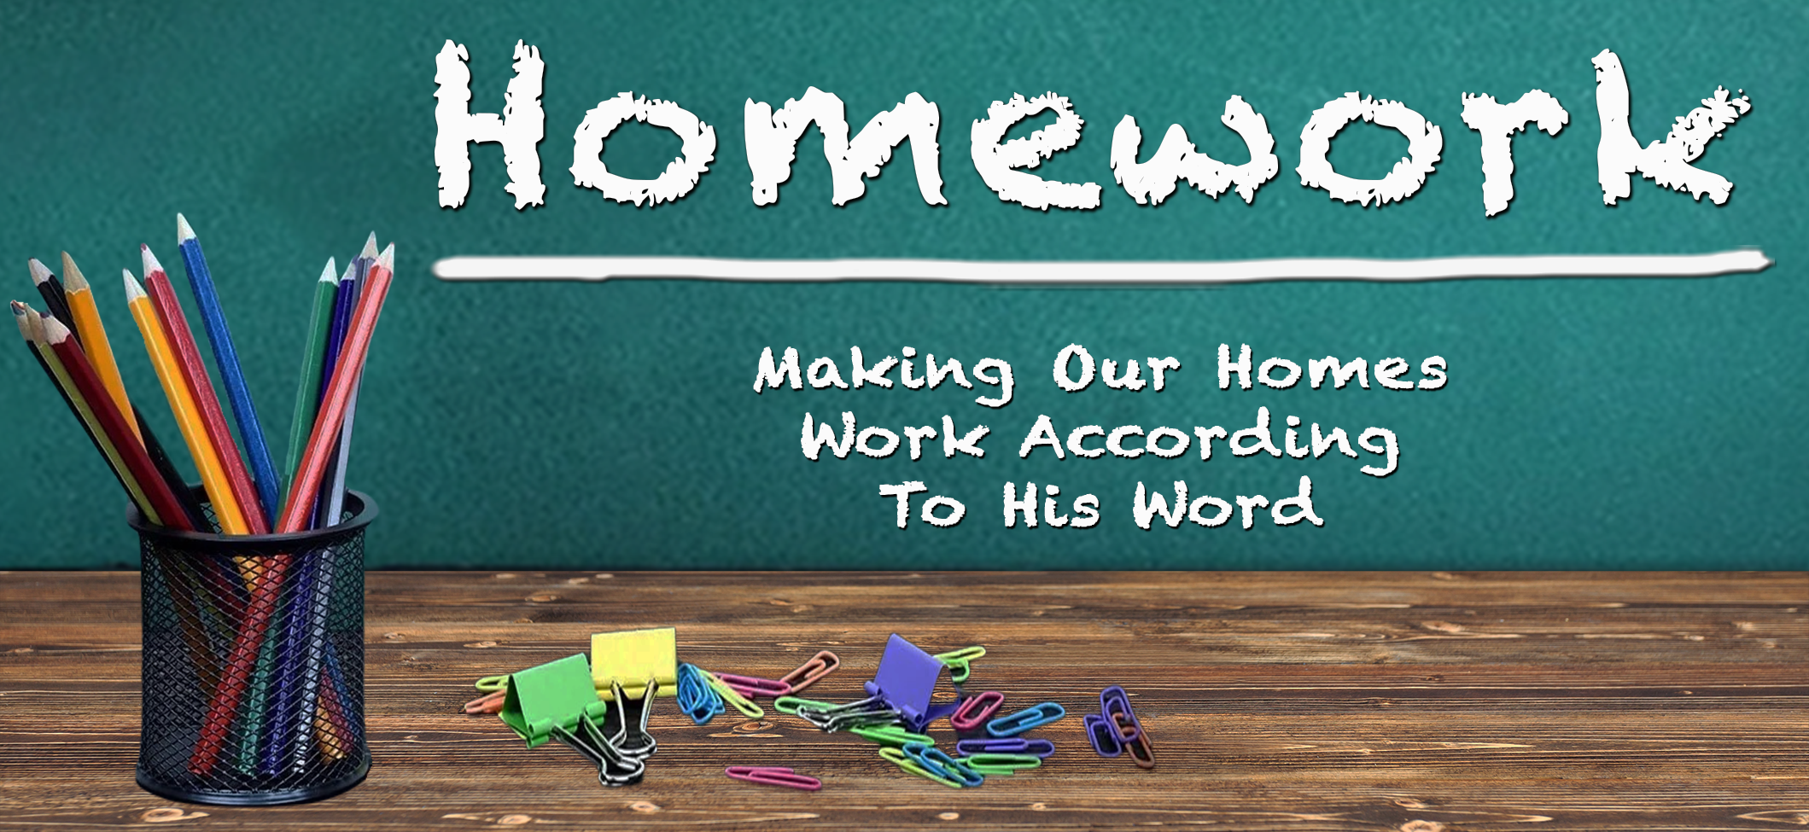
Kid Stuff
June 4th
“Children are a gift from the Lord; they are a reward from him. ⁴ Children born to a young man are like arrows in a warrior’s hands. ⁵ How joyful is the man whose quiver is full of them!”
Psalm 127:3-5 (NLT)

“If you cause one of these little ones who trusts in me to fall into sin, it would be better for you to have a large millstone tied around your neck and be drowned in the depths of the sea.
Matthew 18:6 (NLT)

“Eli's sons were wicked men; they had no regard for the LORD.”
1 Samuel 2:12 (NIV)

Our primary role as parents is to lead our children to become _____________ of _____________.

“Now it was the practice of the priests that, whenever any of the people offered a sacrifice, the priest’s servant would come with a three-pronged fork in his hand while the meat was being boiled ¹⁴ and would plunge the fork into the pan or kettle or caldron or pot. Whatever the fork brought up the priest would take for himself. This is how they treated all the Israelites who came to Shiloh. ¹⁵ But even before the fat was burned, the priest’s servant would come and say to the person who was sacrificing, ‘Give the priest some meat to roast; he won’t accept boiled meat from you, but only raw.’ ¹⁶ If the person said to him, ‘Let the fat be burned first, and then take whatever you want,’ the servant would answer, ‘No, hand it over now; if you don’t, I’ll take it by force.’ ¹⁷ This sin of the young men was very great in the Lord’s sight for they were treating the Lord’s offering with contempt.” 1 Samuel 2:13-17 (NIV)
“Hear, O Israel: The LORD our God, the LORD is one. Love the LORD your God with all your heart and with all your soul and with all your strength. These commandments that I give you today are to be upon your hearts. Impress them on your children. Talk about them when you sit at home and when you walk along the road, when you lie down and when you get up. Tie them as symbols on your hands and bind them on your foreheads. Write them on the doorframes of your houses and on your gates.” Deuteronomy 6:4-9 (NIV)
Kid Stuff
June 4th
Kids’ Stuff
June 4th

“Now Eli, who was very old, heard about everything his sons were doing to all Israel and how they slept with the women who served at the entrance to the Tent of Meeting. So he said to them, ‘Why do you do such things? I hear from all the people about these wicked deeds of yours. No, my sons; it is not a good report that I hear spreading among the Lord's people. If a man sins against another man, God may mediate for him; but if a man sins against the LORD, who will intercede for him?’ His sons, however, did not listen to their father's rebuke…” 1 Samuel 2:22-25 (NIV)

Instill ________________ in your children __________.

“This is what the Lord says to Eli, ‘Why do you scorn my sacrifice and offering that I prescribed for my dwelling? Why do you honor your sons more than me?’” 1 Samuel 2:29 (NIV)

"…Anyone who loves his son or daughter more than me is not worthy of me…” Matthew 10:38a (NIV)

Make your home __________-centered, not __________-centered.

“I have no greater joy than to hear that my children are walking in the truth.” 3 John 4 (NIV)

