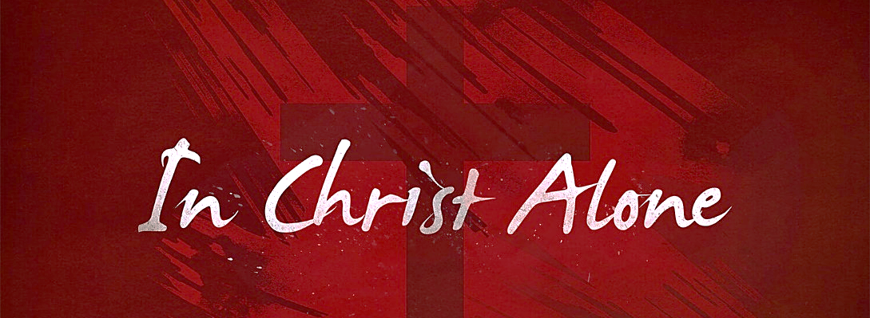

“Our Liberty Is In The Lord” Various Scriptures
July 2nd, 2023

Galatians 5: 1 It is for freedom that Christ has set us free.

WE ARE
______________________________________________________

John 8: 34 – 36 … everyone who sins is a slave to sin. Now a slave has no permanent place in the family, but a son belongs to it forever.
So if the Son sets you free, you will be free indeed.

_______________________________________________________________
_______________________________________________________________
_______________________________________________________________
Luke 4: 18 – 19 The Spirit of the Lord is on me, because he has
anointed me to proclaim good news to the poor. He has sent me to proclaim
freedom for the prisoners and recovery of sight for the blind,
to set the oppressed free, to proclaim the year of the Lord’s favor.

_______________________________________________________________
_______________________________________________________________
_______________________________________________________________

WE ARE ______________________________________________________

Romans 3: 22 – 23 There is no difference between Jew and Gentile,
for all have sinned and fall short of the glory of God

Romans 6: 23 … the wages of sin is death

_______________________________________________________________
_______________________________________________________________

Jesus paid a debt He _________________________________________ …
because we owed a debt _______________________________________.

II Corinthians 5: 21
God made him [Jesus] who had no sin to be sin for us,
so that in him [Jesus] we might become the righteousness of God.

Keys To Our Liberty

C_____________________________________________________

____________________________________________________________
____________________________________________________________

R_____________________________________________________
____________________________________________________________
____________________________________________________________

